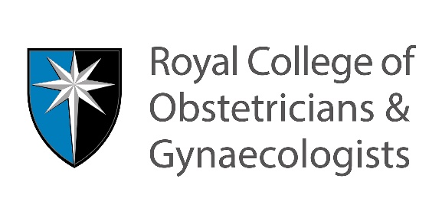
Application for Assessment of Training

Required form for entry to the
MRCOG Part 3 Membership Exam

Personal information

College number:
Last Name:
First Name(s):
Gender:
Date of Birth: | DD/MM/YYYY
(The above must match the information registered on your RCOG website account)

Make sure your postal and email address are up-to-date in your RCOG website account: https://www.rcog.org.uk/en/members/

Medical qualification

University / Medical School name:
Date of graduation:

Medical registration

Applicants registered to practise in the UK or Republic of Ireland | Applicants registered to practice outside the UK or Republic of Ireland
GMC/MCI registration number | Registration number with your national medical council:
Date of entry onto register: | Date of entry onto register:

Please tick the route under which you are applying:
- Route A – Trainees in the recognised UK specialist training programme only

Please state National Training Number:

- Route B – All other applicants

If you are applying for the MTI scheme then please tick this box:

For Route A and Route B candidates please state your training in Obstetrics and Gynaecology to date:

Pre and post-registration refers to the period before and after full registration with your National Medical Council. Any training completed before full registration with your medical council will not be counted towards your training.

Job Title | No. of months | Dates |  | Hospital | Consultant in Charge | Experience Certificate Enclosed
 |  | From | To
GENERAL TRAINING (pre-registration)
Please state your post-registration training in obstetrics and gynaecology to date using the table below. You must have spent a minimum of 4 years of post-registration training in obstetrics and gynaecology.

Route B candidates: For each post, upload a certificate / letter confirming each post-registration position as stated in the Assessment of Training instructions.

Job Title | No. of months | Dates |  | Hospital | Consultant in Charge | Experience Certificate Enclosed
 |  | From | To
OBSTETRICS AND GYNAECOLOGY (recognised, post-registration)

I confirm that I am not currently suspended or removed from medical practice by any authorising body or involved in disciplinary proceedings related to medical practice in any country.

I confirm that I have passed the Part 1 exam.

Signature: |  | Date: | DD/MM/YYYY

Guidance for Assessment of Training Guidance Applications

Information for Route A applicants

- Trainees in a recognised UK specialist training programme must be in intermediate training to be eligible to sit the Part 3 MRCOG examination.
- Trainees must be at ST3 level or above at the date of application for the Assessment of Training.
- Trainees are required to complete an Application for Assessment of Training form, including ticking Route A and providing their National Training Number.
- Candidates are not required to submit any supporting documentation; if the College requires any additional information, the Examination Department will contact candidates via email after receipt of their application.

Information for Route B applicants

- Trainees not in a recognised UK specialist training programme must demonstrate that they have spent a minimum of four years of post-registration training in Obstetrics and Gynaecology.
- Two of these four years must be completed within the last four years preceding a candidate’s original application. Route B applicants are required to submit:

- A copy of your internship / pre-registration certificate (attested copy)
- A copy of your medical registration certificate
- Certificates / letters confirming each post-registration position stated on the form
These must:
- be from your consultants-in-charge or Chair of the Division
- be attested copies (not originals)
- be on official hospital letterhead paper
- state the title / nature and grade of the post
- state the full, exact dates between which the post was held
- not be contract or appointment letters
Experience certificates/letters must be attested with an ink signature by a Fellow or Member of this College, the university or hospital issuing the certificate, the British Council or your embassy, or a solicitor. Any documents submitted along with your application are retained by the Examination Department. Incomplete forms and those where certification has not been submitted for all appointments will not be accepted.

For posts to be recognised, they must be:
- hospital-based in obstetrics and / or gynaecology
- of at least six consecutive months’ duration
Should the Examinations Department require additional experience certificates, candidates must submit these documents within the deadline given. After this period, incomplete Assessment of Training applications will be destroyed and candidates will subsequently be required to submit a new application should they wish to reapply.

All applicants

Sending your application
- Compose a new email
- Use this subject heading “AoT Application [Insert Your College Number]”
- Attach this completed form and all your accompanying documents
- Send your email to AOT@rcog.org.uk. You will then receive an automatic response with details of next steps.

Please note:

- AoT applications can be submitted at any time in accordance with the regulations.
- Please allow up to 4 weeks for your AoT application to be processed.
- All applications must be approved before you can register for the Part 3 exam. Applications will need to be submitted before the relevant AoT closing date, dates are available on our website
- Applicants for the MTI scheme must submit an Assessment of Training application, deadlines are available on our website
- Applications should be accurate and complete at time of submission, incomplete applications will not be processed.

