**This report covers:**

**Collective thematic report sectioned:**

**Advanced; Educational Supervision; Differential Attainment; Gynaecology including Scanning and Workplace Behaviour; Obstetric; and Subspecialty**

**December 2023**

1. Advanced training
2. Educational support and supervision
3. Differential Attainment
4. Obstetric training including scanning
5. Gynaecology training and workplace behaviour scanning
6. Workplace behaviours

Authors: Elizabeth Nevins, John Obodozie, Rozina Mughal and Harriet Gardner

Supervisor: Hannah Gamblin

**Advanced Training**

Author: Dr Harriet Gardner, ST5 Trainee, HEE North East region

Background

* Due to the changing requirements of patients (e.g. an ageing population), and modernisation of healthcare (such as robotic surgery), it is necessary for obstetric and gynaecology training to keep pace. Advanced Training involves trainees choosing an area they wish to develop further, as it is not possible to maintain skills in all areas. It currently consists of ATSMs (Advanced Training Skills Modules) ASMs (Advanced Skills Modules) and APM (Advanced Professional Modules). They usually choose 2 ATSMs, but sometimes if they complete these they may take on a third. ASM/ APMs are optional.
* Changes to Advanced training due to be implemented by 2024 following approval by the GMC. Special Interest Training Modules (SITMs) will replace ATSMs, and Special Interest Professional Modules (SIPMs) will replace APMs (but content will stay the same). Subspecialty curricula will also be updated. This follows the new curriculum which was introduced in 2019 to enable trainees to become consultants that have the skills required to provide excellent patient care. The TEF is used to inform changes to training such as the matrix requirements and training as a whole.
* Subspecialty Training is an optional 3 year program which includes 1 year of research and 2 years clinical. Currently it is possible to undertake in 4 areas: gynaecological oncology, maternal and foetal medicine, reproductive medicine or urogynaecology. With the implementation of the new SITMs the subspecialty curriculum will be made up of the new SITMs and there will be a new research CiP (capability in practice).
* The aim of this report is to analyse responses to the 2023 TEF Questions about Advanced Training

Questions

Questions analysed from the TEF in this report about Advanced Training

|  |  |
| --- | --- |
| Question | Possible Answers |
| 1.11 ST Year | ST6/7 or Post CCT |
| 2.15 Are you currently training Full time or Less Than Full Time (LTFT)? | Full Time/ LTFT 50%/ LTFT 60%/ LTFT 70%/ LTFT 80%/ LTFT 90% |
| 2.11.3 Do you have any additional comments you would like to make on your working environment and rota? (please do not share any names or personal identifiable information as part of your response) | Free text box |
| 2.16.5 My LTFT training does not have a negative impact on my training | Agree/ strongly agree/ neither agree nor disagree/ disagree/ strongly disagree/ n/a |
| 2.14.3 I came in to work on off days or zero days to complete training | Agree/ strongly agree/ neither agree nor disagree/ disagree/ strongly disagree/ n/a |
| 5.1.5 I have had appropriate opportunity to fulfil my training requirements for the year in Advanced procedures (e.g. Laparoscopic management of ectopic pregnancy, surgical management of PPH) | Agree/ strongly agree/ neither agree nor disagree/ disagree/ strongly disagree/ n/a |
| 9.1 Please select the first ATSM you are registered for | Advanced labour ward practice |
| 9.2 Have you completed this ATSM? | Yes/ No |
| 9.4.1 I was able to have an induction/appraisal meeting with my ATSM supervisor for this ATSM | Agree/ strongly agree/ neither agree nor disagree/ disagree/ strongly disagree/ n/a |
| 9.4.2 My induction meeting included an effective assessment of previous experience and competence and my learning needs | Agree/ strongly agree/ neither agree nor disagree/ disagree/ strongly disagree/ n/a |
| 9.4.3 I was able to have regular meetings with my ATSM supervisor to review my progress and ongoing learning needs | Agree/ strongly agree/ neither agree nor disagree/ disagree/ strongly disagree/ n/a |
| 9.4.4 I have had sufficient dedicated ATSM sessions to complete my ATSMs | Agree/ strongly agree/ neither agree nor disagree/ disagree/ strongly disagree/ n/a |
| 9.4.5 If ATSM sessions have not been achieved please give reasons (please do not share any names or personal identifiable information as part of your response) | Free text box |
| 9.4.6 I have had sufficient opportunities to perform surgical/practical procedures for this ATSM | Agree/ strongly agree/ neither agree nor disagree/ disagree/ strongly disagree/ n/a |
| 9.4.7 I have had appropriate supervision for training in these procedures | Agree/ strongly agree/ neither agree nor disagree/ disagree/ strongly disagree/ n/a |
| 9.4.8 I have developed entrustability level 5 in the required areas for this ATSM | Agree/ strongly agree/ neither agree nor disagree/ disagree/ strongly disagree/ n/a |
| 9.4.9 I have had opportunities to attend clinic frequently enough to fulfil my learning needs | Agree/ strongly agree/ neither agree nor disagree/ disagree/ strongly disagree/ n/a |
| 9.4.10 The caseload in this unit provided me with enough experience to complete this ATSM | Agree/ strongly agree/ neither agree nor disagree/ disagree/ strongly disagree/ n/a |
| 9.4.11 I have had appropriate opportunity to fulfil my training requirements for this ATSM | Agree/ strongly agree/ neither agree nor disagree/ disagree/ strongly disagree/ n/a |
| 9.4.12 Could you meet all of your ATSM requirements in your unit? | Yes/ No |
| 9.4.12.2 Was there an opportunity for you to get this experience in another unit? | Yes/ No |
| 9.5 Have you required or do you think you are going to require extra time to complete your ATSM? | Yes/ No |
| 9.6 All things considered I would recommend this unit to other trainees completing the same ATSM | Agree/ strongly agree/ neither agree nor disagree/ disagree/ strongly disagree/ n/a |
| 9.7 How strongly do you agree that this ATSM will adequately prepare you for your special interest areas in your desired job plan? | Agree/ strongly agree/ neither agree nor disagree/ disagree/ strongly disagree/ n/a |
| 9.8 Do you think this ATSM could be improved? | Yes/ No |
| 9.9 How do you think this ATSM could be improved? | Yes/ No |
| 10.1 Are you undertaking subspecialty training? | Yes/ No |
| 10.2 Do you participate in an out of hours (OOH) rota? | Yes/ No |
| 10.3 What is your oncall working pattern? | Full Shift/ resident on call/ non-resident on call |
| 10.4 What does your OOH include? | General Obstetrics and gynaecology / General obstetrics/ general gynaecology/ cover for my subspecialty only |
| 10.5 On average, each month, how many sessions (half days) do you spend doing non-subspecialty sessions (e.g. daytime labour ward/gynaecology on call, non-subspecialty clinics)? | Free text box |
| 10.6 On average, each month, how many sessions (half days) are you not rota’d to be at work as compensatory rest / zero hours for your OOH commitments? | Free text box |
| 10.7 On average, each month, how many rest / zero hours sessions do you not take in order to attend training opportunities? | Free text box |
| 10.8 Has your subspecialty training been extended beyond your initial projected completion date? | Yes/ No |
| 10.9 If you feel your rota does not allow opportunities to undertake all aspects of the training programme, is this because: | You have not been permitted to undertake subspecialty modules due to rota problems?/ The OOH frequency is too great to complete subspecialty training within the given time period?/ The daytime non-subspecialty service commitment is too great to allow completion of subspecialty training within the given time period?/ Other |
| 10.10 Could you meet all of your SST requirements in your unit? | Yes/ No |
| 10.10.1 Which areas/procedures could you not do in your unit? | Free text box |
| 10.10.2 Was there an opportunity for you to get this experience in another unit? | Yes/ No |
| 10.11.1 My OOH commitment does not have a negative impact on training | Agree/ strongly agree/ neither agree nor disagree/ disagree/ strongly disagree/ n/a |
| 10.11.2 The rota allows the opportunity to undertake all aspects of my subspecialty training programme | Agree/ strongly agree/ neither agree nor disagree/ disagree/ strongly disagree/ n/a |
| 10.11.3 I rarely miss specific training sessions to cross cover commitments for others' planned leave | Agree/ strongly agree/ neither agree nor disagree/ disagree/ strongly disagree/ n/a |
| 10.12.1 My subspecialty training programme director has been approachable | Agree/ strongly agree/ neither agree nor disagree/ disagree/ strongly disagree/ n/a |
| 10.12.2 My subspecialty training programme director has been a good teacher | Agree/ strongly agree/ neither agree nor disagree/ disagree/ strongly disagree/ n/a |
| 10.12.3 My subspecialty training programme director has been supportive | Agree/ strongly agree/ neither agree nor disagree/ disagree/ strongly disagree/ n/a |
| 10.12.4 My subspecialty training programme director has taken part in regular and constructive appraisals | Agree/ strongly agree/ neither agree nor disagree/ disagree/ strongly disagree/ n/a |
| 10.13.1 How many other subspecialty clinical trainers/supervisors do you have? | 0-5 |
| 11. What Subspecialty training are you undertaking? | Gynaecological Oncology/ Maternal and Fetal Medicine/ Reproductive Medicine/ Urogynaecology |
| 12.1.1 I have had appropriate opportunity to fulfil my subspecialty training requirements for the year in gynaecology appropriate for my stage of training | Agree/ strongly agree/ neither agree nor disagree/ disagree/ strongly disagree/ n/a |
| 13.1.1 I have had appropriate opportunity to fulfil my subspecialty training requirements for the year in maternal and fetal medicine appropriate for my stage of training | Agree/ strongly agree/ neither agree nor disagree/ disagree/ strongly disagree/ n/a |
| Figure 1. Questions analysed from the 2023 TEF Report on Advanced Training | |

Analysis

ST Year

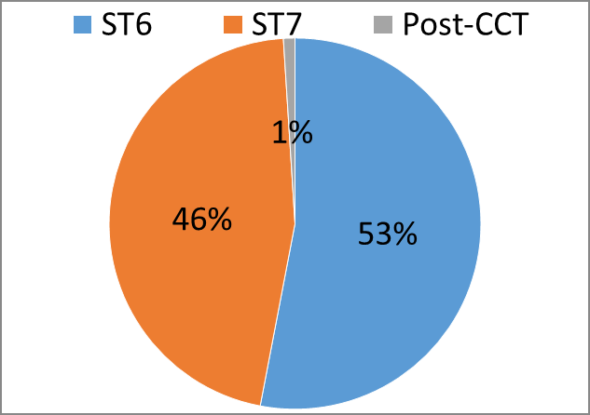

Figure 2. ST Year

Out of the advanced trainees that answered the 2023 TEF, 53% were ST6 and 46% ST7. (1% post CCT).

49% were full time, 51% LTFT (less than full time) ranging from 50-90%. The reasons given for working less than full time are mostly caring responsibilities (83%) but also include religious or unique opportunities (2%) and personal choice (15%).

Distribution of opportunities between trainees

233 agreed and 61 strongly agreed that opportunities were equally distributed between trainees at the same level, (57% overall). 86 disagreed and 35 strongly disagreed (23% overall), 93 (18%) neither agreed nor disagreed.

LTFT Impact on Training

55% agreed or strongly agreed that LTFT didn’t impact negatively on training, while 26% disagreed or strongly disagreed (19% neither agreed nor disagreed).

62% of LTFT trainees came in on their day off to complete training. 118 (23%) said they did note. 78 (15%) “neither agree nor disagree”

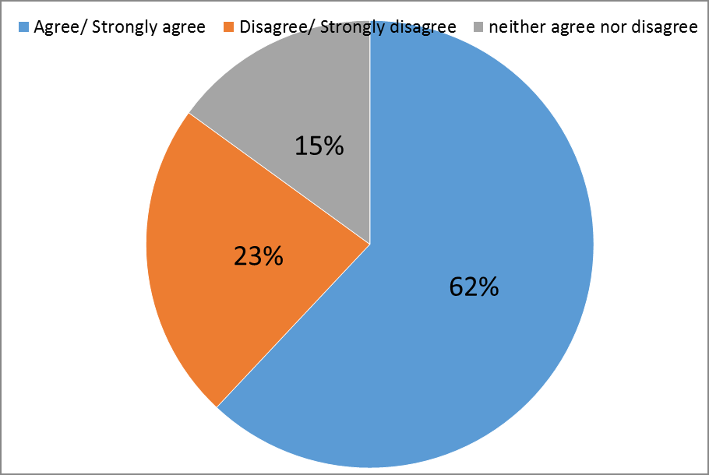

Figure 3. Numbers of trainees who came in on their day off to complete training

2.11.3 Do you have any additional comments about your working environment and rota?

Figure 4. Additional Comments about working environment and rota

Only 20 (4%) had positive additional comments about advanced training in the free text box. There were 19 (4%) “no” comments, leaving 479 (92%) negative comments, the majority citing the rota, staffing and service provision as reasons for lack of ATSM training time.

Advanced Procedures

54% agreed that they have been able to fulfil training requirements in advanced procedures (e.g. laparoscopic management of ectopic pregnancy, surgical management of PPH). 31% disagreed or strongly disagreed, 14% neither agree nor disagree. (The remaining 12% did not respond).

ATSM choices

494 respondents listed their first ATSM choice as follows:

* 38% Advanced labour ward practice
* 13% benign abdominal surgery
* 8% Acute gynaecology and early pregnancy
* 7% oncology
* 4% foetal medicine
* 4% subfertility and reproductive health
* 3% advanced laparoscopic surgery
* 3% obstetric medicine
* 3% high risk pregnancy
* 2% urogynaecology and vaginal surgery
* 3% hysteroscopy
* 1% labour ward lead
* 1% menopause
* <1% (2 people) colposcopy
* <1% (2 people) medical education
* <1% (1 person) paediatric and adolescent gynaecology
* 9% n/a

84% had not completed the ATSM, 16% had (This was mainly due to many having just started it, as explained later).

Induction/appraisal meeting with my ATSM supervisor for this ATSM

75% agreed or strongly agreed that they had an induction meeting with their ATSM supervisor. 7% disagreed or strongly disagreed and 9% neither agreed nor disagreed.

Effective Induction meeting

71% agreed or strongly agreed that their induction meeting included an assessment of previous experience and learning needs.5% disagreed or strongly disagreed with this. 14% neither agree nor disagree or n/a.

71% were able to have regular meetings with their ATSM supervisor to review progress and ongoing learning needs. 9% did not, and the rest were “na” or “neither agree nor disagree”.

I have had sufficient dedicated ATSM sessions to complete my ATSMs

62% of trainees felt they had sufficient dedicated ATSM sessions to complete their ATSMs. 20% disagreed with this statement. (18% answered neither agree nor disagree or n/a).

Reasons for ATSM sessions not being achieved

37% cite the rota, staff shortages or service provision as a reason for ATSM sessions not being achieved. 11% state the reason was that they had just started the ATSM.

I have had sufficient opportunities to perform surgical/practical procedures for this ATSM

64% agreed or strongly disagreed with this statement while 17 disagreed or strongly disagreed. 19% neither agreed nor disagreed or n/a.

I have had appropriate supervision for training in these procedures

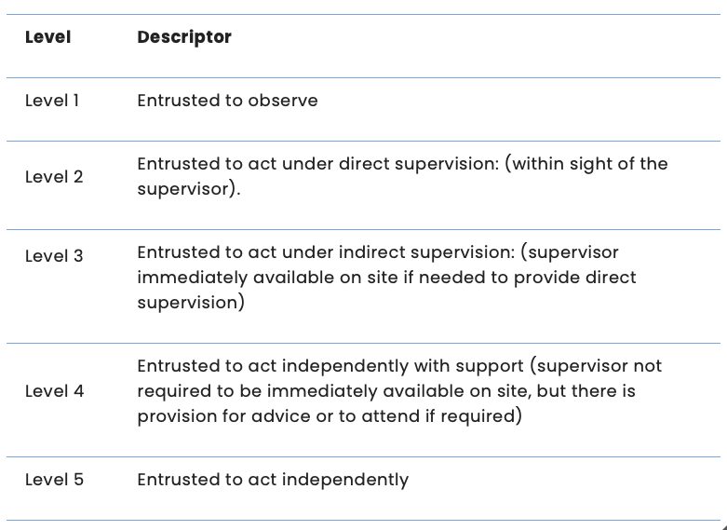

Figure 4. RCOG Entrustability levels for sign-offs

82% felt they had appropriate supervision for training in procedures (agree or strongly agree). 4% disagreed or strongly disagreed, while 14% neither agreed nor disagreed or n/a.

I have developed entrustability level 5 in the required areas for this ATSM

47% felt they had (agreed or strongly agreed) and 25% disagreed or strongly disagreed. (29% neither agreed nor disagreed or n/a)

I have had opportunities to attend clinic frequently enough to fulfil my learning needs

70% agreed or strongly agreed that they had enough clinic opportunities for training. 13% did not.

The caseload in this unit provided me with enough experience to complete this ATSM

74% felt it was, 8% felt it was not. (18% neither agreed nor disagreed or n/a.)

I have had appropriate opportunity to fulfil my training requirements for this ATSM

60% felt they had appropriate opportunity to fulfil training requirements for their ATSM and 15% did not.

Could you meet all of your ATSM requirements in your unit?

83% could fulfil their ATSM requirements in their unit, 17% could not.

Was there an opportunity for you to get this experience in another unit?

Of the 17% that could not meet their ATSM requirements in their unit, 47% said they could in another unit, 53% said they could not.

Have you required or do you think you are going to require extra time to complete your ATSM?

78% felt they didn’t need extra time to complete their ATSM, 22% felt they did.

All things considered I would recommend this unit to other trainees completing the same ATSM

78% agree or strongly agree with this, 9% would not.

How strongly do you agree that this ATSM will adequately prepare you for your special interest areas in your desired job plan?

83% felt the ATSM would adequately prepare them for they desired future jobs. 5% didn’t.

Do you think this ATSM could be improved?

37% felt the ATSM could be improved, 63% felt the ATSM didn’t.

How do you think this ATSM could be improved?

10% cited the fact that labour ward ATSM could be part of the general curriculum

Subspecialty Training

69 Trainees were undertaking subspecialty training. Of these 59 (86%) participated in an out of hours (OOH) rota. 10 did not. 45 were full shift, 20 were resident on call and 4 non-resident.

What does your OOH include?

Most (52) covered general obstetrics and gynaecology, 13 cover for their subspecialty only, 2 general obstetrics, 2 general gynaecology,

The number of sessions (half days) per month spent doing non-subspecialty clinics e.g. labour ward during the day or non-speciality clinics ranged from 0-45, with a median of 2 and a mean of 6 days per month.

The number of sessions (half days) per month that are rest days or zero days after out of hours work ranged from 0-40 with a median of 6 and a mean of 6.

The number of rest sessions (half days) per month not taken by subspecialty trainees in order to attend training sessions ranged from 0-24 with a median of 3 and a mean of 3.

83% completed subspecialty training within the projected time period. 12 out of 69 subspecialty trainees extended their SST beyond the initial projected completion date.

The reasons SST trainees cited for the rota not allowing opportunities cited were 6/69 rota problems, 17/69 OOH frequency too great, 2/69 day time non subspecialty commitments too great, 44/69 stated other, 35 of these (51%) stated that there was no problem, the remaining 11 stated reasons such as sickness, coming in on off days and needing to cover last minute gaps in rota.

As far as achieving SST requirements in their unit, 60 were able to (87%) and 9 were not (13%). Of those 9, 3 mention urogynaecology procedures such as mesh complications, elective urogynaecology lists being cancelled due to bed pressures or competing with ATSM trainees at other units in the region, 2 mention preimplantation genetic testing and 1 mentions foetal interventions which are covered in the second year of the SST programme. 2 mention laparoscopic lymph node dissection but that plans are made to go to another unit in exchange with another trainee. 7/9 (78%) were able to gain this experience in anther unit.

OOH commitment impact on training

45% agreed or strongly agreed that their “OOH commitment does not have a negative impact on training”, while 42% disagreed or strongly disagreed. 13% neither agreed nor disagreed.

Missing training sessions to cover for others’ planned leave

67% agreed or strongly agreed that they rarely miss sessions to cover for planned leave. 10% disagreed or strongly disagreed and 20% neither agreed nor disagreed.

Subspecialty training programme director

96% feel their subspecialty training programme director is approachable, 93% felt they were a good teacher and 94% felt they were supportive. 94% had regular constructive appraisals.

The number of other subspecialty clinical trainers or supervisors ranged from 0-5 with a median and mode of 2.

Subspecialty Choices

* Maternal and Fetal Medicine 25/69 (36%)
* Gynaecological Oncology 20/69 (29%)
* Reproductive Medicine 15/69 (22%)
* Urogynaecology 9/69 (13%)

Fulfilling training requirements

100% of maternal and foetal medicine subspecialty trainees were able to fulfil training requirements for the year and 85% of gynaecological subspecialty trainees.

Findings

The main findings for advanced training on the TEF 2023 was that due to shortages on the rota or service provision, inadequate time was given to ATSM training.

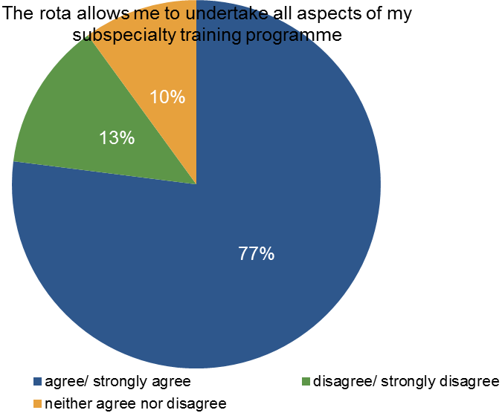

Figure. 4 SST and rota

* Over half (51%) of advanced trainees are less than full time. 62% are having to come in on their days off in order to complete training.
* Most people (75%) were able to have an induction meeting with their ATSM supervisor
* 10% of those that felt the ATSM could be improved suggested that labour ward be part of the general curriculum (which is the aim with the new SITMs coming in next year)
* Sub-speciality trainees feel well supported (93-96%) and 85-100% were able to fulfil their training requirements for the year.

Discussion

* According to the 2023 TEF data, subspecialty trainees feel well supported and able to complete their training requirements. This could be due to the fact that there are fewer subspecialty trainees than ATSM trainees, or that they have 2 clinical years and 1 year of research.
* There is no mention of covid being a factor in surgical training for ATSM in the 2023 TEF, the main reasons cited for lack of theatre opportunity are rota pressures and service provision.

Summary of findings

* Advanced trainees feel they do not have adequate ATSM training due to rota gaps and service provision.
* Subspecialty trainees feel well supported and able to complete training requirements

Recommendations

* Units could step-up ST2s (or ST3s during the day) on the labour ward during the day with supervision of consultants, enabling advanced trainees to be in ATSM sessions.
* Employ trust grade doctors to cover rota gaps, or increase the numbers of intake at ST3 level.
* Trainees need to be proactive in organising regular meetings with their ATSM supervisor and discuss issues early on
* “Neither agree nor disagree” doesn’t work for all questions such as training opportunities being evenly distributed amongst trainees. Maybe future TEFs could have yes/ no/ I don’t know to simplify this and enable more accurate data.
* For a yes/no question (e.g. I was able to have a supervisor induction meeting) the options should have “agree" “disagree” and “n/a” or “yes” “no” “n/a” rather than “agree”, “strongly agree”, “disagree”, “strongly disagree”, “neither agree nor disagree”

**Educational support and supervision**

Author: Dr Elizabeth Nevins, ST7 Trainee, HEE North East region

Background

Effective educational supervision is a key component of trainees’ experience and progress through O&G training. The GMC defines an educational supervisor as someone who “is selected and appropriately trained to be responsible for the overall supervision and management of a specified trainee’s educational progress during a training placement or series of placements”. This includes regular meetings, progress reviews and setting achievable aims for the trainee. They are also required to make a summative judgement about the trainee’s progress at the end of each placement which will assist an ARCP panel in determining progress through training. Educational support will also come from other trainers in the training placement.

The aim of this report is to evaluate trainees experience with educational supervision and support including effectiveness of induction meetings, supervisor familiarity with the RCOG training portfolio and curriculum and the ARCP process.

Questions

Trainees were asked a number of questions in the TEF relating to educational support and supervision. These are listed in the table below.

|  |  |
| --- | --- |
| **Questions** | **Answer options** |
| 3.1.1 To what extent do you agree or disagree with the following statements? |  |
| 3.1.2 I was able to meet with my educational supervisor to set my personalised work schedule within 2 weeks of starting my new post | Yes | No |
| 3.1.3 My induction meeting included an effective assessment of previous experience and competence and my learning needs | Strongly Agree | Agree | Neither Agree nor Disagree | Disagree | Strongly Disagree |
| 3.1.4 I feel well supported by my academic supervisor | Strongly Agree | Agree | Neither Agree nor Disagree | Disagree | Strongly Disagree | N/A |
| 3.1.5 I am able to attend conferences and academic training opportunities | Strongly Agree | Agree | Neither Agree nor Disagree | Disagree | Strongly Disagree | N/A |
| 3.1.6 I have received appropriate academic training e.g. GCP | Strongly Agree | Agree | Neither Agree nor Disagree | Disagree | Strongly Disagree | N/A |
| 3.1.7 My last ARCP was fair | Strongly Agree | Agree | Neither Agree nor Disagree | Disagree | Strongly Disagree | N/A |
| 3.1.8 If you feel your last ARCP was unfair please state why (please do not share any names or personal identifiable information as part of your response) | TEXT |
| 3.1.9 The process for my last ARCP was transparent | Strongly Agree | Agree | Neither Agree nor Disagree | Disagree | Strongly Disagree |
| 3.1.10 My educational supervisor is familiar with the RCOG curriculum | Strongly Agree | Agree | Neither Agree nor Disagree | Disagree | Strongly Disagree |
| 3.1.11 My educational supervisor can use the ePortfolio effectively | Strongly Agree | Agree | Neither Agree nor Disagree | Disagree | Strongly Disagree |

Analysis

In total, 1892 trainees were included in the 2023 TEF and answered questions on educational support and supervision.

Induction meeting with Education supervisor and support

78% of trainees were able to meet with their educational supervisor to set a personalised work schedule within 2 weeks of starting their post. 20% were not able meet their supervisor however there was not additional clarification as to the reasons for this.

84% of trainees agreed (strongly agree or agree) that their induction meeting was an effective assessment of previous competence and learning needs, however 14% did not think this meeting was effective (figure 1). Only 65% of trainees felt well supported by their supervisor. However, this was worded as ‘academic’ supervisor and there may have been some confusion as to whether this question was only for those in academic training as 10% of trainees replied that this was N/A, however all should have an educational supervisor.

Figure 1: Question 3.1.3. Trainees’ perception of the effectiveness of their induction meeting in percentage.

Figure 2: Question 3.1.4 Do trainees feel well supported by their academic supervisor?

Academic training opportunities

Only 61% of trainees agreed (strongly agree or agree) that they were able to attend conferences and academic training opportunities. Over a fifth of trainees are not being given the chance to attend these important learning opportunities (figure 3.).

Trainees are required to also complete appropriate academic training to fulfil their training criteria and to competently practice within Obstetrics and Gynaecology. Only 54% of trainees agreed that they had received this appropriate training (figure 4.). This may be due to a lack of identification of academic training needs or that no time was given to complete these.

Figure 3. Question 3.1.5. Trainee’s ability to attend conferences and academic training opportunities.

Figure 4: Question 3.1.6 Trainees receiving appropriate academic training e.g. GCP.

ARCP process

The majority of trainees (84%) felt that their last ARCP was fair (figure 5.) and 89% felt the ARCP was transparent (figure 6.).

Figure 5: Question 3.1.7 Trainees perception of the fairness of their last ARCP.

The trainees that did not think their ARCP was fair, were additionally asked why they thought it was unfair and most of the answers fell under the following common themes.

* The impact of the COVID pandemic, and delays in achieving competencies due to this, were not considered.
* Educational supervision
  + Educational supervisor not having a full understanding of the e-portfolio and the requirements for ARCP
  + Relevant information not recorded in the education supervisor’s report and therefore not considered by the ARCP panel.
* Lack of effective feedback following ARCP.

Figure 6: Question 3.1.9 Trainees felt the process for ARCP was transparent.

Educational Supervisor familiarity with RCOG curriculum and ePortfolio

A new curriculum was introduced to the RCOG training programme in 2019 and previous TEF reports highlighted that educational supervisors were overall not as familiar with this as necessary. The 2023 TEF results show that 89% of supervisors now have a good understanding of the curriculum (figure 7), and this is a significant improvement from the 57% in 2021. 87% of trainees agreed (strongly agree or agree) that their supervisor could use the ePortfolio effectively (figure 8).

Figure 7. Question 3.1.10 Educational supervisors have a good understanding of the RCOG training curriculum.

Figure 8. Question 3.1.11. Educational supervisors can use the ePortfolio effectively.

Discussion

Overall, the majority of responses in regard to education supervision were positive. Most felt able to meet with their ES in the first two weeks of starting a new post and agreed that this meeting was constructive and comprehensive of their training progress and needs. This forms an essential part of the training process and should be a constructive meeting with the identification of clear goals and objectives and a realistic and practical learning plan put in place.

87% of trainees felt that their ES could use the e-portfolio effectively, and 89% felt that their ES was familiar with the RCOG curriculum. This is a large improvement from 2021 TEF, where only 57% of trainees thought their ES was familiar with the curriculum. This is likely the result of increasing experience and familiarity with the new curriculum since its introduction in 2019. There were still a number of trainees however, who felt their ES was not as familiar or knowledgeable as they would wish, and that this compromised their progress though training and/or ARCP outcome. The RCOG roles and responsibilities of the educational supervisor include that they should be familiar with the structure of the training programme, as well as their role in the ARCP process before they begin an educational supervisor post. This ensures all trainees are given the best opportunities and guidance to be able to progress through their training. Deaneries and those appointing educational supervisors should ensure that all supervisors have the level of understanding required before assigning trainees to them. This could be done through training sessions and mentoring schemes.

The lowest positive responses (<75% strongly agree or agree) were to the questions discussing academic opportunities and ability to attend training courses or conferences. These opportunities are essential for learning and competency achievement, as well as a number being mandatory in both the Matrix and ARCP requirements. Trainees should be supported to attend these where appropriate. Opportunities may be limited by service provision or the prioritising of other practical leaning needs, however as a number are mandatory or are significantly beneficial for training, a review by departments should be undertaken if trainees are not achieving these learning opportunities. This should be discussed between the trainee and their educational supervisor at each meeting and highlighted to the department and/or deanery for action when an issue is identified.

The results of the 2021 TEF showed a significant impact to training from the COVID pandemic and fewer than 50% of trainees felt they had adequate gynaecology training and training in ultrasound procedures, with obstetric training being less affected. The impact of the covid pandemic on training will be felt for years to come and this should still be considered during supervision meetings and ARCP. Many trainees felt that, despite efforts to compensate for this, they are still disadvantaged during their training and ARCP reviews. Educational supervisors need to address this with each trainee at the induction meeting and together make a comprehensive and achievable catch-up plan.

The ARCP process is a significant undertaking by both the trainee and the ARCP panel. It should be comprehensive, productive, and informative to the trainee. Significant weight is given to the ES report when awarding outcomes and therefore this needs to be completed fully and with recommendations included for future learning goals and placements to maximise exposure to training needs. Specific feedback and recommendations should also be given to trainees by the ARCP panel so that they can review this with their ES and include these in their objectives for the following training post.

Summary of findings

* Overall, educational support and supervision is a positive experience for trainees on the RCOG training programme.
* Trainees are losing out on opportunities to attend courses, conferences, and academic opportunities.
* There is still a significant impact from COVID that is not always being fully recognised at the supervision/ARCP level.
* There must be a minimal level of knowledge, training, and competence for all educational supervisors.
* The ARCP process is mainly considered fair however improvements could be made with evidence review and feedback to trainees.

Recommendations

* All educational supervisors need to have completed local and deanery ES training and should familiarise themselves with the new RCOG curriculum. This should be reviewed at a deanery level to ensure each supervisor has a minimum level of knowledge prior to trainees being allocated.
* Educational supervisors and trainees to make a personalised and achievable plan for COVID catch up during the induction meeting. This should be followed up at subsequent meetings and action taken if this is not being achieved.
* Trainees should be strongly supported to attend educational courses and conferences appropriate to their training needs and encouraged to complete appropriate academic training. This should be reviewed at each educational supervisor meeting and escalated within the department/deanery if not being achieved.
* ES and trainee to document any additional evidence in the ES report that they wish to be considered for the ARCP panel.
* ARCP panels to give specific feedback to each trainee with aims and progress targets for the following year.

**Differential Attainment**

Authors: Dr John Obodozie, ST6 Trainee, HEE North East region; Dr Hannah Gamblin, Consultant, HEE North East region

Background

The RCOG undertakes annually a detailed analysis of select key areas of training. This is according to current priorities identified by the Specialty Education Advisory Committee (SEAC) and the Trainees' Committee. All available data is analysed and combined into reports that are then fed back to SEAC, Heads of School, the Trainees’ Committee and the GMC via the Annual Specialty Report. The information is used to reward good training, as a driver for change and to identify ways to improve training. In addition, the analysis is used to inform changes to the Training Evaluation Form (TEF) and the GMC survey program-specific questions.

There was no TEF in 2020. This is because the RCOG postponed it due to the Covid-19 pandemic. The last TEF for comparison was in 2019. This report is an analysis of the 2021 TEF. The categories for the thematic reports for TEF 2021 cover:

*i. Gynaecology training - lack of access to surgical procedures*

ii. *Subspecialty training - effects on progression of training*

iii. *Workplace Behaviours - promote understanding and consistency across regions*

iv. *Differential Attainment - deferments, regional teaching issues*

v. *Covid effect - clinical and non-clinical which would overlap with above categories*

vi. *New curriculum - to include the educational supervision component*

Questions

|  |  |  |
| --- | --- | --- |
| 1.3 | Would you describe yourself as: | Male | Female | Non-binary | Prefer not to say | Prefer to self-describe  (please describe) |
| 1.4 | Which of these best describes your ethnic group? | Asian or Asian British - Indian | Asian or Asian British - Pakistani | Asian or Asian British - Bangladeshi | Asian or Asian British - Chinese | Asian or Asian British - Other | Black, Black British, Caribbean or African - Caribbean | Black, Black British, Caribbean or African - African | Black, Black British, Caribbean or African - Other | Mixed or multiple ethnic groups - White and Black Caribbean | Mixed or multiple ethnic groups - White and Black African | Mixed or multiple ethnic groups - White and Asian | Mixed or multiple ethnic groups - Other | White - English, Welsh, Scottish, Northern Irish or British | White - Irish | White - Gypsy or Irish Traveller | White - Roma | White - Other | Other - Arab | Any other Ethnic Group| I do not wish to disclose |
| 1.5 | Where is your Primary Medical Degree awarded from? | UK | EEA | IMG (Please specify) |
| 2.14.4 | Training opportunities are distributed equitably amongst all Trainees/Trainees at the same stage of training in my current unit | Strongly Agree | Agree | Neither Agree nor Disagree | Disagree | Strongly Disagree |
| 2.15 | Are you currently training Full time or Less Than Full Time (LTFT)? | Full time | LTFT 50% | LTFT 60% | LTFT 70% | LTFT 80% | LTFT 90% | Other (please specify) |
| 2.16.5 | My LTFT training does not have a negative impact on my training | Strongly Agree | Agree | Neither Agree nor Disagree | Disagree | Strongly Disagree |
| 19.1 | Do you feel you are actively supported to achieve more in your career  for example: opportunities to undertake projects, preference for training opportunities, support for exam prep | Yes | No |
| 19.2 | What do you think are the barriers to this? | ES indifference |Unconscious racial bias |Conscious racial bias |Unconscious gender bias |Conscious gender bias |Other (please specify) |
| 19.3 | I feel that equality, diversity and fairness are embedded in my training and learning environment | Strongly Agree | Agree | Neither Agree nor Disagree | Disagree | Strongly Disagree |
| 19.4 | My workplace-based assessments are fair and unbiased | Strongly Agree | Agree | Neither Agree nor Disagree | Disagree | Strongly Disagree |
| 19.5.1 | I have NOT been discriminated against in my training | Strongly Agree | Agree | Neither Agree nor Disagree | Disagree | Strongly Disagree |

Analysis

**Gender**

There were 1892 responses to the question relating to gender. The breakdown is seen below.

**Ethnicity**

There were 1892 responses to the question related to ethnicity. Respondents were also able to self-identify. Their responses have been grouped to aid analysis. See figure below.

**Location of Primary Medical Qualification (PMQ)**

There were 1892 responses to the question related to PMQ. Doctors from the UK, the European Economic Area (EEA) or where International Medical Graduates (IMG). The breakdown is shown in the figure below.

**Subspecialty training (SST)**

There were 75 respondents enrolled in SST. Male trainees were slightly more likely to be in SST programmes (6.1%) than female trainees (3.53%). This has widened compared to 2022 with 4.5% proportion of trainees that identified as male and 3.95% of trainees that identify as Female. IMG graduates were least likely to be enrolled in SST at (1.50%) whilst EEA graduates were most likely at 7.60%.



**Less than full time (LTFT)**

There were 1892 responses related to the questions related to working the LTFT. Most LTFT trainees were Category 1 LTFT.

Male trainees were more likely to be Fulltime 84.9% compared to 59.2% of females. See figure below.

Black respondents had the highest proportion of Fulltime trainees (79.2%) with those that identify as White having the least proportion of fulltime trainees (58.4%).

**Active support for career progression**

There were 1892 responses to the statement ‘Do you feel you are actively supported to achieve more in your career’. 377 (20%) of respondents disagreed. Respondents that identified as white were least likely to not feel actively supported at 16% compared to other ethnicities while Respondents that identified as Female were more likely to not feel actively supported to achieve more in their career at 19.9% compared to counterparts that identify as Males. See figures below



Perceived barriers to active support.

A number of potential barriers to respondents being actively supported to achieve more in their careers were analysed. 5% of respondents cited ES indifference as a potential barrier to being actively supported. Respondents were more likely to site unconscious racial bias (4%) over conscious racial bias (1%).

Respondents were more likely to site unconscious racial bias (4%) over conscious racial bias (1%). 25 out of 197 (12.7%) of respondents that identify as Black sited unconscious racial bias compared to 5 out of 995 (0.5%) respondents that identify as white.

Likewise, respondents were also more likely to site unconscious gender bias (2%) over conscious gender bias (0.5%). 10 out of 344 (2.9%) of respondents that identify as male sited unconscious gender bias compared to 27 out of 1499 (1.8%) respondents that identify as female.

**Embedded equality, diversity and fairness**

There were 1892 respondents to the question ‘I feel that equality, diversity and fairness are embedded in my training and learning environment’ of which 117 (6%) either disagreed or strongly disagreed. Respondents that identified as white were least likely to either disagree or strongly disagree at 3% compared to those that identified as either Mixed or Black at 12% and 11% respectively.

**Fair and unbiased workplace-based assessments**.

There were 1892 respondents to the question ‘my workplace-based assessments were fair and unbiased’. Only 1.3% of respondents either disagreed or strongly disagreed with the statement.

**Discrimination in training**

100 (5.29%) of 1892 respondents disagreed or strongly disagreed with the statement ‘I have NOT been discriminated against in my training’. Respondents that identified as Males or White were least likely to report discrimination in training at 3.8% and 3.1% respectively.

Respondents that identify as Black were most likely to report discrimination in training at 10% (20 out of 197).

Summary of findings

This report identified several areas of differential attainment, particularly in regards to discrimination in training, support during serious incidents, experience of persistent bullying behaviours and access to SST.

White trainees are more likely to pass MRCOG than their BME counterparts, with significant differences in pass rates even among UK graduates. Access to SST showed clear differential attainment, with black trainees making up only a tiny proportion of this training grade.

Non-white trainees were the most likely to report experiencing persistent behaviours and Asian trainees were the most likely to report lack of support during serious incidents.

Despite raising these issues as actions following the previous TEF, there does not appear to have been significant change. It is not possible to say if previously noted issues have been addressed; however, given the importance of ensuring equality, diversity and inclusion (EDI) in the O&G workforce, this will remain a priority in future TEF analyses.

**Gynaecology Training including scanning, and Workplace Behaviour**

Author: Dr Rozina Mughal ST7 Trainee, North East region

Background

The aim of this report is to summarise the findings of the national trainee evaluation form that is carried out annually.

I was looking at 3 areas:

1. Gynaecology training
2. Gynaecology scanning
3. Workplace behaviour

Section 1 – Gynaecology training

Questions

|  |  |
| --- | --- |
| 5.1.1 | I have had appropriate opportunity to fulfil my training requirements for the year in gynaecology |
| 5.1.2 | I had sufficient opportunities based on my curriculum needs and stage of training to develop my Gynaecological surgical skills in: |
| 5.1.3 | Basic procedures (e.g. surgical management of miscarriage) |
| 5.1.4 | Intermediate procedures (e.g. diagnostic laparoscopy, simple operative laparoscopy ) |
| 5.1.5 | Advanced procedures (e.g. Laparoscopic management of ectopic pregnancy, surgical management of PPH) |
| 5.1.6 | Emergency procedures |
| 5.1.7 | Outpatient/ office procedures |
| 5.1.8 | I have had appropriate supervision for my level of training in gynaecology theatre – elective cases |
| 5.1.9 | Trainers were supportive in completing the required gynaecology workplace-based assessments |
| 5.1.10 | My clinical supervisors have provided me with feedback that is constructive and helpful |
| 5.1.11 | I have had opportunities to attend gynaecology clinic frequently enough to fulfil my learning needs |
| 5.1.12 | I have had appropriate supervision for my level of training in gynaecology clinic |
| 5.1.13 | I have had appropriate supervision for my level of training in gynaecology outside of normal hours |
| 5.1.14 | I have had the opportunity to attend specialist clinics (e.g. urogynaecology, fertility and paediatric and adolescent clinics) |
| 5.2 | I have had access to a laparoscopic box trainer or virtual reality simulator |
| 5.3 | There was a formal programme of simulation training in gynaecological procedural skills |
| 5.4 | All things considered I would recommend this unit to other O&G trainees for the development of their gynaecology skills |

Analysis

1787 trainees answered this part of the survey. Overall, most trainees agreed that they felt that they had appropriate opportunity to fulfil their training requirements for the year in gynaecology (47%). With regards to having opportunities needed to develop surgical skills- 75% of trainees agreed they had enough opportunities for basic procedures, 43% agreed for intermediate procedures and 26% agreed for advanced procedures. Half of trainees agreed that they had enough opportunities to develop emergency procedures, and for office gynaecology procedures again half of trainees agreed and disagreed that they had enough opportunity to fulfil requirements. The vast majority of trainees agreed that they had appropriate levels of supervision in gynaecology theatre during elective cases. Most trainees agreed that trainers filled out WBAs in time, and also that they were provided with helpful constructive feedback. Approximately half of trainees agreed that they had opportunity to attend gynaecology clinic, but when in clinic, almost all trainees agreed that they were suitably supervised. 73% of trainees agreed that they were appropriately supervised for gynaecology out of hours. Only 31% of trainees agreed that they had enough opportunity to attend specialty gynaecology clinics.

With regards to box trainers and VR simulators, 582 trainees said they did not have access to either. Most trainees had access, but only to a box trainer. Most trainees disagreed that there was a formal programme of simulation training.

Overall, 53% of trainees would have recommended their unit for gynaecology training, 24% would not have, with the rest neither agreeing nor disagreeing or stating n/a.

The following graphs are included for information.

Section 2: Gynaecology Scanning

Questions

|  |  |
| --- | --- |
| 7.5.1 | I have had adequate opportunities for training in Ultrasound examination in gynaecology |
| 7.5.2 | I have had adequate opportunities for assessment in Ultrasound examination in gynaecology |
| 7.5.3 | Once I was assessed as competent in Ultrasound examination in gynaecology, I had the opportunity to maintain my skills |
| 7.6 | Are you undertaking Ultrasound examination of early pregnancy complications? |
| 7.6.1 | I have had adequate opportunities for training in Ultrasound examination of early pregnancy complications |
| 7.6.2 | I have had adequate opportunities for assessment in Ultrasound examination of early pregnancy complications |
| 7.6.3 | Once I was assessed as competent in Ultrasound examination of early pregnancy complications, I had the opportunity to maintain my skills |
| 7.7 | Are you undertaking Transvaginal examination in late pregnancy (cervical length and placental assessment)? |
| 7.7.1 | I have had adequate opportunities for training in Transvaginal examination in late pregnancy (cervical length and placental assessment) |
| 7.7.2 | I have had adequate opportunities for assessment in Transvaginal examination in late pregnancy (cervical length and placental assessment) |
| 7.7.3 | Once I was assessed as competent in Transvaginal examination in late pregnancy (cervical length and placental assessment), I had the opportunity to maintain my skills |

Analysis

Out of 1851 trainees who answered, 486 are undertaking ultrasound in gynaecology and 1365 are not. Around 60% of trainees said that they had adequate opportunities for training in Ultrasound examination in gynaecology, and approximately 53% of trainees said the same for assessment.

Most trainees are also not undertaking ultrasound examination of early pregnancy complications (1469 trainees out of 1851). Within this, most trainees agreed that they had adequate opportunities for training and assessment as shown in the graphs below. Of those undertaking early pregnancy ultrasound, 46% said they were able to maintain their skills once competent.

264 trainees are undertaking ultrasound in late pregnancy (cervical length and placental assessment). Of these, 185 agreed that they had adequate opportunity for training and 179 agreed that they had adequate opportunity for assessment. After gaining competence, 148 said they were able to maintain skills.

Section 3: Workplace Behaviour

Questions

|  |  |
| --- | --- |
| 17.1.1 | In this post, I was NOT subjected to persistent behaviours by others which have eroded my professional confidence or self esteem |
| 17.1.2 | Did you report it? |
| 17.1.3 | What was the outcome? |
| 17.1.4 | Further comments (please do not share any names or personal identifiable information as part of your response) |
| 17.1.5 | Why did you not report it? |
| 17.1.6 | Further comments (please do not share any names or personal identifiable information as part of your response) |
| 17.2.1 | In this post, I did NOT witness other specialist trainees being subjected to persistent behaviours by others which has eroded their professional confidence or self esteem |
| 17.2.2 | Did you report it? |
| 17.2.3 | What was the outcome? |
| 17.2.4 | Further comments (please do not share any names or personal identifiable information as part of your response) |
| 17.2.5 | Why did you not report it? |
| 17.2.6 | Further comments (please do not share any names or personal identifiable information as part of your response) |
| 17.3.1 | Please identify the types of behaviour you have witnessed or being subjected to (please select ALL that apply) |
| 17.3.2 | Please state who has subjected you or other work colleagues to inappropriate behaviour (please select ALL that apply) |
| 17.4.1 | In this post, I did NOT witness other healthcare professionals (e.g. non-trainee doctor, midwife, AHP) being subjected to persistent behaviours by others which have eroded their professional confidence or self esteem |
| 17.4.2 | Further comments (please do not share any names or personal identifiable information as part of your response) |
| 17.5.1 | In this post, I was SUBJECTED TO or WITNESSED behaviour that I would classify as 'incivility' (incivility is one or more rude, discourteous, or disrespectful action that may or may not have a negative intent behind them) |
| 17.5.2 | Further comments (please do not share any names or personal identifiable information as part of your response) |
| 17.6.1 | I am aware that my deanery has a REGIONAL Workplace Behaviour Champion |
| 17.6.2 | I know who my Regional Workplace Behaviour Champion is |
| 17.6.3 | Have you contacted them? |
| 17.6.4 | If you contacted them did you find this helpful |
| 17.6.5 | Further comments (please do not share any names or personal identifiable information as part of your response) |
| 17.7 | As an O&G trainee in this unit, I feel valued in the workplace |
| 17.8 | This unit has a sense of community and belonging |
| 17.9.1 | In this post, I have witnessed behaviour which I would consider commendable |

Analysis

1851 trainees answered this part of the survey. 78% trainees agreed or strongly agreed that they had not been subject to persistent behaviours by others which have eroded professional confidence or self-esteem. Of those that did, 105 trainees reported it and 110 did not, so almost a 50-50 split. The type of persistent behaviour experienced is demonstrated in the graph below, with attempts to belittle and undermine being experienced most commonly. Consultants within the department were the most commonly occurring perpetrator as shown in the graph.

245 trainees disagreed that they hadn’t witnessed other specialist trainees experience these persistent behaviours. Of those that did witness it, 186 did not report it, and only 78 did. 991 trainees disagreed that they witnessed behaviour that they would class as ‘incivility’. Most (1140) trainees are aware that they have a regional workplace behaviour champion. 65% of trainees do not know who their workplace behaviour champion is and 93% have not contacted them. Of those who did, 70% did not find it helpful.

Most trainees agree or strongly agree that they feel valued in the workplace, and that their unit has a sense of community and belonging. 83% of trainees have witnessed behaviour that they would describe as commendable, with a positive work environment, valuing trainee wellbeing and good support following adverse events being the most commonly occurring examples of commendable behaviour.

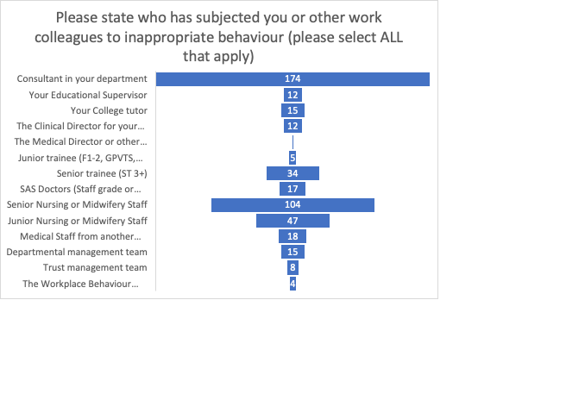

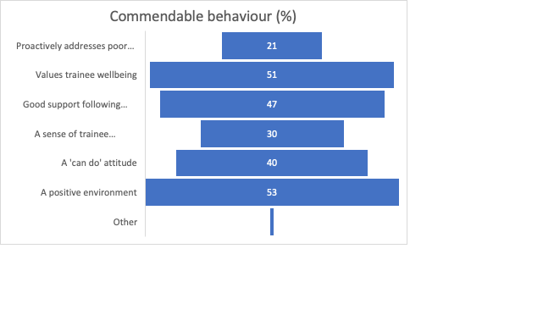

**Obstetric training including Ockenden, and Ultrasound Training**

Author: Dr Elizabeth Nevins, ST7 Trainee, HEE North East region

Background

Obstetric training is one of the core aspects of the RCOG training programme. The RCOG matrix of progression, as well as the core curriculum (2019), set out the required criteria for trainees to progress and complete training. Each trainee is expected to obtain a minimum standard of competence. Training placements, the trainers working in them, and the opportunities provided, should enable trainees to achieve this.

The Ockenden report was published in 2022 following a review of maternity services in the Shrewsbury and Telford Hospital NHS Trust. The report gave 15 main recommendations to be implemented nationally to improve maternity care and neonatal outcomes. This report has impacted everyday practice on the labour ward and many of the recommendations are relevant to the RCOG training programme.

Ultrasound is used daily as part of obstetrics and gynaecology practice. It is an essential practical skill which is a component of core, ATSM and subspecialty training. All trainees are expected to achieve a minimum level of ‘basic’ scanning competency, and this is done through a combination of training, assessment, and continuing practice. Trainees may then opt to undertake intermediate and advanced training modules and should have adequate opportunities for training in these if chosen.

Questions

The following tables outline the questions from the 2023 TEF that relate to Obstetric and Ultrasound training.

**Obstetric training questions (including Ockenden)**

|  |  |  |
| --- | --- | --- |
| Question Number | Question | Answer |
| 6.1 | To what extent do you agree or disagree with the following statements? |  |
| 6.1.1 | I have had appropriate opportunity to fulfil my training requirements for the year in obstetrics | Strongly Agree | Agree | Neither Agree nor Disagree | Disagree | Strongly Disagree | N/A |
| 6.1.2 | I had sufficient opportunities based on my curriculum needs to perform caesarean section delivery appropriate to my level of training | Strongly Agree | Agree | Neither Agree nor Disagree | Disagree | Strongly Disagree | N/A |
| 6.1.3 | I had sufficient opportunities based on my curriculum needs to perform operative vaginal delivery appropriate to my level of training | Strongly Agree | Agree | Neither Agree nor Disagree | Disagree | Strongly Disagree | N/A |
| 6.1.4 | I have had appropriate supervision & support whilst on labour ward – outside of normal working hours | Strongly Agree | Agree | Neither Agree nor Disagree | Disagree | Strongly Disagree | N/A |
| 6.1.5 | Trainers were supportive in completing the required obstetric workplace-based assessments | Strongly Agree | Agree | Neither Agree nor Disagree | Disagree | Strongly Disagree | N/A |
| 6.1.6 | My clinical supervisors have provided me with feedback that is constructive and helpful | Strongly Agree | Agree | Neither Agree nor Disagree | Disagree | Strongly Disagree | N/A |
| 6.1.7 | I have had opportunities to attend antenatal clinics frequently enough to fulfil my learning needs | Strongly Agree | Agree | Neither Agree nor Disagree | Disagree | Strongly Disagree | N/A |
| 6.1.8 | I have had appropriate supervision for my level of training in antenatal clinic | Strongly Agree | Agree | Neither Agree nor Disagree | Disagree | Strongly Disagree | N/A |
| 6.1.9 | I have had the opportunity to attend specialist antenatal clinics (e.g. fetal medicine and maternal medicine) | Strongly Agree | Agree | Neither Agree nor Disagree | Disagree | Strongly Disagree | N/A |
| 6.1.10 | All things considered I would recommend this unit to other O&G trainees for the development of their obstetric skills | Strongly Agree | Agree | Neither Agree nor Disagree | Disagree | Strongly Disagree | N/A |
|  |  |  |
| 2.13.2 | Consultant is present at labour ward shift handover |  |
| 2.13.2.1 | Weekday in morning | Yes |No |
| 2.13.2.2 | Weekday in afternoon | Yes |No |
| 2.13.2.3 | Weekday in evening | Yes |No |
| 2.13.2.4 | Weekend in morning | Yes |No |
| 2.13.2.5 | Weekend in afternoon | Yes |No |
| 2.13.2.6 | Weekend in evening | Yes |No |

**Ultrasound training Questions**

|  |  |  |
| --- | --- | --- |
| Question Number | Question | Answer |
| 7.1 | To what extent do you agree or disagree with the following statements? |  |
| 7.1.1 | I have had adequate opportunities for training in Transabdominal examination of early pregnancy (<14) | Strongly Agree | Agree | Neither Agree nor Disagree | Disagree | Strongly Disagree | N/A |
| 7.1.2 | I have had adequate opportunities for assessment in Transabdominal examination of early pregnancy (<14) | Strongly Agree | Agree | Neither Agree nor Disagree | Disagree | Strongly Disagree | N/A |
| 7.1.3 | Once I was assessed as competent in Transabdominal examination of early pregnancy (<14)I had the opportunity to maintain my skills | Strongly Agree | Agree | Neither Agree nor Disagree | Disagree | Strongly Disagree | N/A |
| 7.1.4 | I have had adequate opportunities for training in Transabdominal examination in later pregnancy (>14) | Strongly Agree | Agree | Neither Agree nor Disagree | Disagree | Strongly Disagree | N/A |
| 7.1.5 | I have had adequate opportunities for assessment in Transabdominal examination in later pregnancy (>14) | Strongly Agree | Agree | Neither Agree nor Disagree | Disagree | Strongly Disagree | N/A |
| 7.1.6 | Once I was assessed as competent in Transabdominal examination in later pregnancy (>14), I had the opportunity to maintain my skills | Strongly Agree | Agree | Neither Agree nor Disagree | Disagree | Strongly Disagree | N/A |
| 7.2 | Do opportunities for regional ultrasound experience exist if not available in your base hospital? | Yes | No |
| 7.3 | Are you undertaking Transabdominal assessment of normal fetal anatomy? | Yes | No |
| 7.3.1 | I have had adequate opportunities for training in Transabdominal assessment of normal fetal anatomy | Strongly Agree | Agree | Neither Agree nor Disagree | Disagree | Strongly Disagree | N/A |
| 7.3.2 | I have had adequate opportunities for assessment in Transabdominal assessment of normal fetal anatomy | Strongly Agree | Agree | Neither Agree nor Disagree | Disagree | Strongly Disagree | N/A |
| 7.3.3 | Once I was assessed as competent in Transabdominal assessment of normal fetal anatomy, I had the opportunity to maintain my skills | Strongly Agree | Agree | Neither Agree nor Disagree | Disagree | Strongly Disagree | N/A |
| 7.4 | Are you undertaking transabdominal assessment of fetal biometry? | Yes | No |
| 7.4.1 | I have had adequate opportunities for training in transabdominal assessment of fetal biometry | Strongly Agree | Agree | Neither Agree nor Disagree | Disagree | Strongly Disagree | N/A |
| 7.4.2 | I have had adequate opportunities for assessment in transabdominal assessment of fetal biometry | Strongly Agree | Agree | Neither Agree nor Disagree | Disagree | Strongly Disagree | N/A |
| 7.4.3 | Once I was assessed as competent in transabdominal assessment of fetal biometry, I had the opportunity to maintain my skills | Strongly Agree | Agree | Neither Agree nor Disagree | Disagree | Strongly Disagree | N/A |
| 7.5 | Are you undertaking Ultrasound examination in gynaecology? | Yes | No |
| 7.5.1 | I have had adequate opportunities for training in Ultrasound examination in gynaecology | Strongly Agree | Agree | Neither Agree nor Disagree | Disagree | Strongly Disagree | N/A |
| 7.5.2 | I have had adequate opportunities for assessment in Ultrasound examination in gynaecology | Strongly Agree | Agree | Neither Agree nor Disagree | Disagree | Strongly Disagree | N/A |
| 7.5.3 | Once I was assessed as competent in Ultrasound examination in gynaecology, I had the opportunity to maintain my skills | Strongly Agree | Agree | Neither Agree nor Disagree | Disagree | Strongly Disagree | N/A |
| 7.6 | Are you undertaking Ultrasound examination of early pregnancy complications? | Yes | No |
| 7.6.1 | I have had adequate opportunities for training in Ultrasound examination of early pregnancy complications | Strongly Agree | Agree | Neither Agree nor Disagree | Disagree | Strongly Disagree | N/A |
| 7.6.2 | I have had adequate opportunities for assessment in Ultrasound examination of early pregnancy complications | Strongly Agree | Agree | Neither Agree nor Disagree | Disagree | Strongly Disagree | N/A |
| 7.6.3 | Once I was assessed as competent in Ultrasound examination of early pregnancy complications, I had the opportunity to maintain my skills | Strongly Agree | Agree | Neither Agree nor Disagree | Disagree | Strongly Disagree | N/A |
| 7.7 | Are you undertaking Transvaginal examination in late pregnancy (cervical length and placental assessment)? | Yes | No |
| 7.7.1 | I have had adequate opportunities for training in Transvaginal examination in late pregnancy (cervical length and placental assessment) | Strongly Agree | Agree | Neither Agree nor Disagree | Disagree | Strongly Disagree | N/A |
| 7.7.2 | I have had adequate opportunities for assessment in Transvaginal examination in late pregnancy (cervical length and placental assessment) | Strongly Agree | Agree | Neither Agree nor Disagree | Disagree | Strongly Disagree | N/A |
| 7.7.3 | Once I was assessed as competent in Transvaginal examination in late pregnancy (cervical length and placental assessment), I had the opportunity to maintain my skills | Strongly Agree | Agree | Neither Agree nor Disagree | Disagree | Strongly Disagree | N/A |

Analysis

**Obstetric Training**

The 2023 TEF included 1892 trainees on the RCOG training programme, across England, Northern Ireland, Scotland, and Wales.

**General Obstetrics**

Evaluation of ‘general obstetrics’ training is used in the TEF as one of the ‘main indicators’ of the overall quality of the RCOG training programme.

Overall, 78% of trainees agreed (strongly agree or agree) that they had appropriate opportunities to fulfil their training requirements for obstetrics in the training year. 7% felt they disagreed or strongly disagreed. 79% of trainees recommended their current unit to others for the development of their obstetric skills.

84% felt that trainers were supportive in completing obstetric work-based assessments and 85% thought they received constructive and helpful feedback.

78% agreed that they had sufficient opportunity to attend antenatal clinics, with 77% agreeing they had appropriate supervision, however only 48% agreed that they had the opportunity to attend specialist antenatal clinics e.g., maternal medicine or fetal medicine.

Figure 1 shows the RCOG main indicators results for general obstetrics training, ordered by deanery, and is a score of the overall results from general obstetrics training questions. This shows that most trainees had a positive experience, however there is significant inter- deanery variation.

Additional Ockenden Considerations

85% if trainees felt they had appropriate supervision of the labour ward outside of normal working hours.

Figure 2 shows the percentage of consultant presence at ward rounds in the morning, afternoon and evenings during both weekdays and weekends. This is significantly higher during weekdays. Trainees were more likely to say their presence is not applicable during the afternoon ward rounds, however there was no clarification as to whether this was due to no ward round taking place or departments not requiring consultant presence at this time.

Obstetric Procedures

Questions 6.1.2 & 6.1.3 relate to trainees’ opportunities with obstetric procedures during their training placement, these include caesarean and instrumental deliveries only.

86% had sufficient opportunities to perform caesarean sections at the level they required for training and 71% felt they had sufficient opportunity to perform vaginal deliveries.

Figure 3 shows the RCOG overall main indicator result for the questions relating to obstetric procedures for each deanery, again showing significant variation in trainees experience depending on the region of training.

Ultrasound training

**Basic Ultrasound Training**

The basic ultrasound questions 7.1.1, 7.1.2, 7.1.4 & 7.1.5 are also used as a main indicators in the TEF.

Only 32% of trainees agreed (agree or strongly agree) that they had adequate opportunity for training in transabdominal (TA) early pregnancy (<14 weeks) scanning. 44% felt they did not (disagree or strongly disagree) have adequate opportunities for training in this area. 30% felt they had adequate opportunity for assessment in TA early pregnancy scanning and only 24% agreed that they were given the opportunity to maintain this skill once they were deemed competent.

44% of trainees agreed that they had adequate opportunity for training in TA later pregnancy (>14 weeks) scanning. 35% felt they did not have adequate training in this area.

39% agreed that they had adequate opportunity for assessment and 34% felt they were given the opportunity to maintain this skill once they were deemed competent.

Figure 4 shows the main indicator scores for basic ultrasound training in each deanery. Most scored less than 50%, with Northern Ireland being a clear positive outlier.

When trainees were not able to gain ultrasound experience in their own hospital, 34% were aware of opportunities to obtain this regionally, 15% said there were no regional opportunities and 39% were unsure if any regional opportunities existed (the remaining 12% did not answer this question or it was not applicable to their training needs).

Intermediate and Advanced Ultrasound training

303 (16%) respondents were undertaking TA scanning of normal fetal anatomy, 435 (23%) of respondents were undertaking TA scanning of fetal biometry, 486 (25%) of respondents were undertaking ultrasound examination in gynaecology, 382 (20%) of respondents were undertaking ultrasound examination of early pregnancy complications and 265 (14%) of respondents were undertaking TV ultrasound in later pregnancy.

Figure 5 shows the percentages of trainees who strongly agreed or agreed that they had adequate opportunities for training, assessment, and maintenance of these scanning skills. Overall, there was higher satisfaction with scanning in obstetrics than scanning in gynaecology. Only around half of trainees are being given the opportunity to maintain these scanning competencies once achieved.

Discussion

General obstetrics training is one of the core aspects of the RCOG training programme. The 2023 TEF results show that most trainees are placed in appropriate centres to meet their training needs for the year. However, over one fifth of trainees did not have sufficient training opportunities available in their placement. This may be for a number of reasons; Firstly, there are variations between units; for example, tertiary centres are likely to provide a wider range of training opportunities than a district general hospital however, training opportunities may also be lost due to service provision. With increasing rota gaps, and departments prioritising the staffing of basic services, learning opportunities are inevitably lost which has a significant negative impact on training and the ability to achieve the required competencies of the training programme. Ideally, once a competency is achieved, time should also be given to maintaining these competencies. This will maintain a skilled workforce and ensure patient safety.

The Ockenden report was published in 2022 following a review of maternity services in the Shrewsbury and Telford NHS trust. It gave fifteen main recommendations, and some of those relevant to the RCOG training programme have been reviewed in this report. One of these recommendations is to ensure that staff can escalate concerns if necessary. This includes the appropriate support and supervision of trainees whilst on the labour ward, as well as a minimum specified consultant presence (e.g. at handovers). 15% of trainees did not feel they had appropriate support and supervision on the labour ward, which is significant, given the Ockenden findings, and is a patient safety issue which needs to be addressed within each unit. In addition, the RCOG Roles and Responsibilities of a consultant providing acute care in Obstetrics and Gynaecology, states that a consultant should attend if asked to do so. Trainees need to feel reassured and empowered to ask for assistance should they feel the need, no matter what the circumstances.

The findings from the 2023 TEF show that basic ultrasound training in the RCOG training programme is overall poor with less than half of trainees agreeing that they had sufficient training opportunities in ultrasound and only around a third finding that they had the appropriate chance for assessment and to maintain competency. The exception to this is training in Northern Ireland.

Ultrasound scanning is an essential daily skill in both Obstetrics and Gynaecology and therefore competency is essential. Training is mainly practical rather than theoretical and can be done on simulators, but essential ‘real life’ training should also be provided. This is mainly in specific ultrasound sessions but can also be ad-hoc, such as during on-call, in clinics, or in theatres.

There may be several reasons why trainees are not getting the opportunity for basic scan training, including the need for service provision and other training needs e.g., general obstetrics and gynaecology competencies, taking priority. In Northern Ireland, trainees are required to scan patients as part of their routine clinic consultations and so this is likely the reason for the additional ultrasound training opportunities in this deanery.

When ultrasound training opportunities are not available in a certain training centre, regional opportunities should be available for affected trainees. These could include access to ultrasound trainers/simulators as well as dedicated ultrasound sessions in alternative units with the facilities to provide the training required. Only 34% of trainees were aware of such opportunities with 15% saying that none were available in their deanery. 39% were unsure if any were available. Trainees need to be made aware of the availability of these facilities and sessions and given information on how to organise them as part of their induction into the department.

Summary of findings

* Overall, general obstetrics training is good however a fifth of trainees are not able to fulfil their learning requirements within the training year.
* Not all trainees are receiving appropriate supervision and support and supervision on labour ward which needs to be addressed urgently as a patient safety consideration.
* Ultrasound training throughout obstetrics and gynaecology is overall poor. Trainees need significantly more opportunities for training, competency assessment and maintenance of skills.

Recommendations

* Educational supervisor to review progress and training needs at each meeting. If training needs are not being met, a robust plan with specific, achievable recommendations needs put in place. This may include working within the department to prioritise the trainee attending certain sessions, attending these at another centre or attending courses or simulated sessions.
* The educational supervisors report should include a recommendation of the appropriate centre for the trainee’s next placement, according to their training needs. This should be reviewed by the ARCP panel, and the trainee placed in an appropriate centre.
* Additional training opportunities should be identified regionally, and provision made for trainees to attend these throughout the year if required.
* Trainees to be informed at induction of the department’s guidelines for consultant presence on the labour ward and given assurances that consultants will attend when asked to do so.
* Each deanery should identify ultrasound training opportunities e.g., simulator availability and regional additional training sessions, for trainees unable to achieve their learning needs in their current placement. This should be clearly communicated at departmental induction and by the deanery at the start of the training year.

**Subspecialty Training**

Author: Dr John Obodozie, ST6 Trainee, HEE North East region

Background

The RCOG undertakes annually a detailed analysis of select key areas of training. This is according to current priorities identified by the Specialty Education Advisory Committee (SEAC) and the Trainees' Committee. All available data is analysed and combined into reports that are then fed back to SEAC, Heads of School, the Trainees’ Committee and the GMC via the Annual Specialty Report. The information is used to reward good training, as a driver for change and to identify ways to improve training. In addition, the analysis is used to inform changes to the Training Evaluation Form (TEF) and the GMC survey program-specific questions.

There was no TEF in 2020. This is because the RCOG postponed it due to the Covid-19 pandemic. The last TEF for comparison was in 2021. This report is an analysis of the 2022 TEF. The categories for the thematic reports for TEF 2022 cover:

*i. Gynaecology training - lack of access to surgical procedures*

ii. *Subspecialty training - effects on progression of training*

iii. *Workplace Behaviours - promote understanding and consistency across regions*

iv. *Differential Attainment - deferments, regional teaching issues*

v. *Covid effect - clinical and non-clinical which would overlap with above categories*

vi. *New curriculum - to include the educational supervision component*

The focus of this report is **Subspecialty Training**.

Questions

|  |  |  |  |
| --- | --- | --- | --- |
| 10 | **Subspecialty Training** |  | SST |
| 10.1 | Are you undertaking Subspecialty Training? | Yes | No | SST |
| 10.2 | Do you participate in an out of hours (OOH) rota? | Yes | No | SST |
| 10.3 | What is your oncall working pattern? | Full shift | On-call resident | On-call (non-resident) | SST |
| 10.4 | What does your OOH include? | Cover for my subspecialty only | General Obstetrics & Gynaecology |  General Obstetrics |General Gynaecology | SST |
| 10.5 | On average, each month, how many sessions (half days) do you spend doing non-subspecialty sessions (e.g. daytime labour ward/gynaecology on call, non-subspecialty clinics)? | 0 | 1 | 2 | 3 | 4 | 5 | 6 | 7 | 8 | 9 | 10 | 11 | 12 | 13 | 14 | 15 | 16 | 17 | 18 | 19 | 20 | 21 | 22 | 23 | 24 | 25 | 26 | 27 | 28 | 29 | 30 | 31 | 32 | 33 | 34 | 35 | 36 | 37 | 38 | 39 | 40 | 41 | 42 | 43 | 44 | 45 | 46 | 47 | 48 | 49 | 50 | SST |
| 10.6 | On average, each month, how many sessions (half days) are you not rota’d to be at work as compensatory rest / zero hours for your OOH commitments? | 0 | 1 | 2 | 3 | 4 | 5 | 6 | 7 | 8 | 9 | 10 | 11 | 12 | 13 | 14 | 15 | 16 | 17 | 18 | 19 | 20 | 21 | 22 | 23 | 24 | 25 | 26 | 27 | 28 | 29 | 30 | 31 | 32 | 33 | 34 | 35 | 36 | 37 | 38 | 39 | 40 | 41 | 42 | 43 | 44 | 45 | 46 | 47 | 48 | 49 | 50 | SST |
| 10.7 | On average, each month, how many rest / zero hours sessions do you not take in order to attend training opportunities? | 0 | 1 | 2 | 3 | 4 | 5 | 6 | 7 | 8 | 9 | 10 | 11 | 12 | 13 | 14 | 15 | 16 | 17 | 18 | 19 | 20 | 21 | 22 | 23 | 24 | 25 | 26 | 27 | 28 | 29 | 30 | 31 | 32 | 33 | 34 | 35 | 36 | 37 | 38 | 39 | 40 | 41 | 42 | 43 | 44 | 45 | 46 | 47 | 48 | 49 | 50 | SST |
| 10.8 | Has your subspecialty training been extended beyond your initial projected completion date? | Yes | No | SST |
| 10.9 | If you feel your rota does not allow opportunities to undertake all aspects of the training programme, is this because: | You have not been permitted to undertake subspecialty modules due to rota problems? |  The OOH frequency is too great to complete subspecialty training within the given time period? |  The daytime non-subspecialty service commitment is too great to allow completion of subspecialty training within the given time period? | Other (please specify) | SST |
| 10.10 | Could you meet all of your SST requirements in your unit? | Yes | No | SST |
| 10.10.1 | Which areas/procedures could you not do in your unit? | Free text | SST |
| 10.10.2 | Was there an opportunity for you to get this experience in another unit? | Yes | No | SST |
| 10.11 | To what extent do you agree or disagree with the following statements? |  | SST |
| 10.11.1 | My OOH commitment does not have a negative impact on training | Strongly Agree | Agree | Neither Agree nor Disagree | Disagree | Strongly Disagree | N/A | SST |
| 10.11.2 | The rota allows the opportunity to undertake all aspects of my subspecialty training programme | Strongly Agree | Agree | Neither Agree nor Disagree | Disagree | Strongly Disagree | N/A | SST |
| 10.11.3 | I rarely miss specific training sessions to cross cover commitments for others planned leave | Strongly Agree | Agree | Neither Agree nor Disagree | Disagree | Strongly Disagree | N/A | SST |
| 10.12 | The following are Trainer related questions: |  | SST |
| 10.12.1 | My subspecialty training programme director has been approachable | Strongly Agree | Agree | Neither Agree nor Disagree | Disagree | Strongly Disagree | N/A | SST |
| 10.12.2 | My subspecialty training programme director has been a good teacher | Strongly Agree | Agree | Neither Agree nor Disagree | Disagree | Strongly Disagree | N/A | SST |
| 10.12.3 | My subspecialty training programme director has been supportive | Strongly Agree | Agree | Neither Agree nor Disagree | Disagree | Strongly Disagree | N/A | SST |
| 10.12.4 | My subspecialty training programme director has taken part in regular and constructive appraisals | Strongly Agree | Agree | Neither Agree nor Disagree | Disagree | Strongly Disagree | N/A | SST |
| 10.13 | Other Trainers: |  | SST |
| 10.13.1 | How many other subspecialty clinical trainers / supervisors do you have? | 0 | 1 | 2 | 3 | 4 | 5 | SST |
| 10.13.2 | My clinical supervisors have provided me with feedback that is constructive and helpful | Strongly Agree | Agree | Neither Agree nor Disagree | Disagree | Strongly Disagree | N/A | SST |
| 10.13.3 | This trainer has been approachable | Strongly Agree | Agree | Neither Agree nor Disagree | Disagree | Strongly Disagree | N/A | SST |
| 10.13.4 | This trainer has been a good teacher | Strongly Agree | Agree | Neither Agree nor Disagree | Disagree | Strongly Disagree | N/A | SST |
| 10.13.5 | This trainer has been supportive | Strongly Agree | Agree | Neither Agree nor Disagree | Disagree | Strongly Disagree | N/A | SST |
| 10.13.6 | This trainer has taken part in regular and constructive appraisals | Strongly Agree | Agree | Neither Agree nor Disagree | Disagree | Strongly Disagree | N/A | SST |
| 11 | What Subspecialty training are you undertaking? | Gynaecological Oncology |  Maternal and Fetal Medicine |  Reproductive Medicine |          Urogynaecology | DEMOGRAPHIC |
| 12 | **SST Gynaecological Oncology** |  | SST - GO |
| 12.1 | To what extent do you agree or disagree with the following statements? |  | SST - GO |
| 12.1.1 | I have had appropriate opportunity to fulfil my subspecialty training requirements for the year in gynaecology appropriate for my stage of training | Strongly Agree | Agree | Neither Agree nor Disagree | Disagree | Strongly Disagree | N/A | SST - GO |
| 12.1.2 | I have had sufficient opportunities based on my curriculum needs and stage of training to develop my gynaecological surgical skills in: |  | SST - GO |
|  | Major procedures |  | SST - GO |
| 12.1.3 | Open | Strongly Agree | Agree | Neither Agree nor Disagree | Disagree | Strongly Disagree | N/A | SST - GO |
| 12.1.4 | Laparoscopic | Strongly Agree | Agree | Neither Agree nor Disagree | Disagree | Strongly Disagree | N/A | SST - GO |
| 12.1.5 | Radical hysterectomy | Strongly Agree | Agree | Neither Agree nor Disagree | Disagree | Strongly Disagree | N/A | SST - GO |
| 12.1.6 | Debulking surgery | Strongly Agree | Agree | Neither Agree nor Disagree | Disagree | Strongly Disagree | N/A | SST - GO |
| 12.1.7 | Pelvic node dissection | Strongly Agree | Agree | Neither Agree nor Disagree | Disagree | Strongly Disagree | N/A | SST - GO |
| 12.1.8 | Radical Vulval surgery | Strongly Agree | Agree | Neither Agree nor Disagree | Disagree | Strongly Disagree | N/A | SST - GO |
| 12.1.9 | Groin node surgery | Strongly Agree | Agree | Neither Agree nor Disagree | Disagree | Strongly Disagree | N/A | SST - GO |
| 12.1.10 | I have had appropriate supervision for my level of training in gynaecology theatre – elective cases | Strongly Agree | Agree | Neither Agree nor Disagree | Disagree | Strongly Disagree | N/A | SST - GO |
| 12.1.11 | I have had appropriate supervision for my level of training in managing emergency gynaecology cases | Strongly Agree | Agree | Neither Agree nor Disagree | Disagree | Strongly Disagree | N/A | SST - GO |
| 12.1.12 | Trainers were supportive in completing the required gynaecology workplace-based assessments | Strongly Agree | Agree | Neither Agree nor Disagree | Disagree | Strongly Disagree | N/A | SST - GO |
| 12.1.13 | My clinical supervisors have provided me with feedback that is constructive and helpful | Strongly Agree | Agree | Neither Agree nor Disagree | Disagree | Strongly Disagree | N/A | SST - GO |
| 12.1.14 | I have had sufficient exposure to the multidisciplinary meeting frequently enough to fulfil my learning needs | Strongly Agree | Agree | Neither Agree nor Disagree | Disagree | Strongly Disagree | N/A | SST - GO |
| 12.1.15 | I have had appropriate supervision for my level of training in gynaecology clinic | Strongly Agree | Agree | Neither Agree nor Disagree | Disagree | Strongly Disagree | N/A | SST - GO |
| 12.1.16 | I have had the opportunity to commence my modules and / or have a plan to complete them | Strongly Agree | Agree | Neither Agree nor Disagree | Disagree | Strongly Disagree | N/A | SST - GO |
| 12.1.17 | All things considered I would recommend this centre to other trainees who wish to attain gynaecology subspecialty training | Strongly Agree | Agree | Neither Agree nor Disagree | Disagree | Strongly Disagree | N/A | SST - GO |
| 12.2 | I have had access to a laparoscopic box trainer or virtual reality simulator | No | Yes, box trainer only | Yes, virtual reality simulator only |Yes, box trainer & virtual reality simulator | SST - GO |
| 12.3 | There was a formal programme of simulation training in gynaecological procedural skills | Yes | No | SST - GO |
| 13 | **SST Maternal and Fetal Medicine** |  | SST - MFM |
| 13.1 | To what extent do you agree or disagree with the following statements? |  | SST - MFM |
| 13.1.1 | I have had appropriate opportunity to fulfil my subspecialty training requirements for the year in maternal and fetal medicine appropriate for my stage of training | Strongly Agree | Agree | Neither Agree nor Disagree | Disagree | Strongly Disagree | N/A | SST - MFM |
| 13.1.2 | I have had adequate opportunities for training in high level obstetric ultrasound | Strongly Agree | Agree | Neither Agree nor Disagree | Disagree | Strongly Disagree | N/A | SST - MFM |
| 13.1.3 | I have had adequate opportunities for training in invasive prenatal diagnostic procedures (CVS/amniocentesis) | Strongly Agree | Agree | Neither Agree nor Disagree | Disagree | Strongly Disagree | N/A | SST - MFM |
| 13.1.4 | I have had adequate opportunities for observation of higher level invasive fetal medicine procedures such as IUT and laser | Strongly Agree | Agree | Neither Agree nor Disagree | Disagree | Strongly Disagree | N/A | SST - MFM |
| 13.1.5 | I have had adequate exposure to fetal medicine to achieve my training goals for this year | Strongly Agree | Agree | Neither Agree nor Disagree | Disagree | Strongly Disagree | N/A | SST - MFM |
| 13.1.6 | I have had adequate supervision in fetal medicine clinics | Strongly Agree | Agree | Neither Agree nor Disagree | Disagree | Strongly Disagree | N/A | SST - MFM |
| 13.1.7 | I have had adequate exposure to a multidisciplinary approach to maternal medicine to achieve my training goals for this year | Strongly Agree | Agree | Neither Agree nor Disagree | Disagree | Strongly Disagree | N/A | SST - MFM |
| 13.1.8 | I have had adequate supervision in maternal medicine clinics | Strongly Agree | Agree | Neither Agree nor Disagree | Disagree | Strongly Disagree | N/A | SST - MFM |
| 13.1.9 | I have had adequate opportunity to be observed counselling patients in complex clinical situations | Strongly Agree | Agree | Neither Agree nor Disagree | Disagree | Strongly Disagree | N/A | SST - MFM |
| 13.1.10 | I have had sufficient exposure to specialist medical clinics to achieve my training goals this year | Strongly Agree | Agree | Neither Agree nor Disagree | Disagree | Strongly Disagree | N/A | SST - MFM |
| 13.1.11 | I have had sufficient exposure to perinatal pathology to achieve my training goals this year | Strongly Agree | Agree | Neither Agree nor Disagree | Disagree | Strongly Disagree | N/A | SST - MFM |
| 13.1.12 | I have had sufficient exposure to neonatal surgery to achieve my training goals this year | Strongly Agree | Agree | Neither Agree nor Disagree | Disagree | Strongly Disagree | N/A | SST - MFM |
| 13.1.13 | I have had sufficient time and encouragement to complete work place based assessments | Strongly Agree | Agree | Neither Agree nor Disagree | Disagree | Strongly Disagree | N/A | SST - MFM |
| 13.1.14 | I have received sufficient feedback from my trainers | Strongly Agree | Agree | Neither Agree nor Disagree | Disagree | Strongly Disagree | N/A | SST - MFM |
| 14 | **SST Reproductive Medicine** |  | SST - RM |
| 14.1 | To what extent do you agree or disagree with the following statements? |  | SST - RM |
| 14.1.1 | My schedule was tailored to my learning objectives | Strongly Agree | Agree | Neither Agree nor Disagree | Disagree | Strongly Disagree | N/A | SST - RM |
| 14.1.2 | I have had opportunities to attend specialist clinics frequently enough to fulfil my learning needs | Strongly Agree | Agree | Neither Agree nor Disagree | Disagree | Strongly Disagree | N/A | SST - RM |
| 14.1.3 | I have had adequate supervision in these specialist clinics appropriate to my level of training | Strongly Agree | Agree | Neither Agree nor Disagree | Disagree | Strongly Disagree | N/A | SST - RM |
| 14.1.4 | I have had opportunities to demonstrate my patient communication / counselling skills to my trainer | Strongly Agree | Agree | Neither Agree nor Disagree | Disagree | Strongly Disagree | N/A | SST - RM |
| 14.1.5 | I have had adequate opportunities to discuss complex cases with my trainers | Strongly Agree | Agree | Neither Agree nor Disagree | Disagree | Strongly Disagree | N/A | SST - RM |
| 14.1.6 | I have had adequate exposure to a multidisciplinary approach to reproductive medicine to achieve my training goals for this year | Strongly Agree | Agree | Neither Agree nor Disagree | Disagree | Strongly Disagree | N/A | SST - RM |
| 14.1.7 | I have had appropriate supervision for surgical/practical procedures | Strongly Agree | Agree | Neither Agree nor Disagree | Disagree | Strongly Disagree | N/A | SST - RM |
| 14.1.8 | The case load of this unit provides a broad spectrum of surgical/practical procedures | Strongly Agree | Agree | Neither Agree nor Disagree | Disagree | Strongly Disagree | N/A | SST - RM |
| 14.1.9 | I have had adequate opportunities to complete work place based assessments | Strongly Agree | Agree | Neither Agree nor Disagree | Disagree | Strongly Disagree | N/A | SST - RM |
| 14.1.10 | I have received appropriate feedback from my trainers | Strongly Agree | Agree | Neither Agree nor Disagree | Disagree | Strongly Disagree | N/A | SST - RM |
| 14.1.11 | All things considered I would recommend this unit to other subspecialty trainees in RM | Strongly Agree | Agree | Neither Agree nor Disagree | Disagree | Strongly Disagree | N/A | SST - RM |
| 14.2 | I have had adequate opportunities to perform the following surgical/practical procedures relevant to my level of training year |  | SST - RM |
| 14.2.1 | Ultrasound scans | Strongly Agree | Agree | Neither Agree nor Disagree | Disagree | Strongly Disagree | N/A | SST - RM |
| 14.2.2 | Oocyte retrievals | Strongly Agree | Agree | Neither Agree nor Disagree | Disagree | Strongly Disagree | N/A | SST - RM |
| 14.2.3 | Embryo transfers | Strongly Agree | Agree | Neither Agree nor Disagree | Disagree | Strongly Disagree | N/A | SST - RM |
| 14.2.4 | Operative Hysteroscopic procedures | Strongly Agree | Agree | Neither Agree nor Disagree | Disagree | Strongly Disagree | N/A | SST - RM |
| 14.2.5 | Operative (intermediate to advanced levels) Laparoscopic procedures | Strongly Agree | Agree | Neither Agree nor Disagree | Disagree | Strongly Disagree | N/A | SST - RM |
| 14.2.6 | Andrology procedures (such as SSR) | Strongly Agree | Agree | Neither Agree nor Disagree | Disagree | Strongly Disagree | N/A | SST - RM |
| 15 | **SST Urogynaecology** |  | SST - UG |
| 15.1 | To what extent do you agree or disagree with the following statements? |  | SST - UG |
| 15.1.1 | I have had appropriate opportunity to fulfil my training requirements for the year in urogynaecology | Strongly Agree | Agree | Neither Agree nor Disagree | Disagree | Strongly Disagree | N/A | SST - UG |
| 15.1.2 | Opportunities for minor procedures (e.g. cystoscopy, bulking agents, suprapubic catheterization etc.) have been available | Strongly Agree | Agree | Neither Agree nor Disagree | Disagree | Strongly Disagree | N/A | SST - UG |
| 15.1.3 | Opportunities for intermediate procedures (e.g. TVT, anterior repair, posterior repair, mesh revision etc.) have been available | Strongly Agree | Agree | Neither Agree nor Disagree | Disagree | Strongly Disagree | N/A | SST - UG |
| 15.1.4 | Opportunities for major procedures have been available | Strongly Agree | Agree | Neither Agree nor Disagree | Disagree | Strongly Disagree | N/A | SST - UG |
| 15.1.5 | Opportunity for Emergency procedures (repair of OASI) have been available | Strongly Agree | Agree | Neither Agree nor Disagree | Disagree | Strongly Disagree | N/A | SST - UG |
| 15.1.6 | I have had adequate supervision for surgical procedures | Strongly Agree | Agree | Neither Agree nor Disagree | Disagree | Strongly Disagree | N/A | SST - UG |
| 15.1.7 | Outpatient/ office procedures have been undertaken (e.g. Botox) | Strongly Agree | Agree | Neither Agree nor Disagree | Disagree | Strongly Disagree | N/A | SST - UG |
| 15.1.8 | Trainers were supportive in completing the required urogynaecology workplace-based assessments | Strongly Agree | Agree | Neither Agree nor Disagree | Disagree | Strongly Disagree | N/A | SST - UG |
| 15.1.9 | My clinical supervisors have provided me with feedback that is constructive and helpful | Strongly Agree | Agree | Neither Agree nor Disagree | Disagree | Strongly Disagree | N/A | SST - UG |
| 15.1.10 | I have had the opportunity to attend specialist clinics (e.g. perineal trauma, urology, colorectal, GI physiology and continence clinics) | Strongly Agree | Agree | Neither Agree nor Disagree | Disagree | Strongly Disagree | N/A | SST - UG |
| 15.1.11 | I have found urogynaecology clinics a useful training opportunity with adequate exposure to new and complex cases | Strongly Agree | Agree | Neither Agree nor Disagree | Disagree | Strongly Disagree | N/A | SST - UG |
| 15.1.12 | I have had the opportunity to demonstrate my patient communication/counselling skills to my trainer | Strongly Agree | Agree | Neither Agree nor Disagree | Disagree | Strongly Disagree | N/A | SST - UG |
| 15.1.13 | I have had opportunities to discuss cases with my trainer | Strongly Agree | Agree | Neither Agree nor Disagree | Disagree | Strongly Disagree | N/A | SST - UG |
| 15.1.14 | I have had ample opportunities to develop my vaginal surgical skills / opportunities for operating | Strongly Agree | Agree | Neither Agree nor Disagree | Disagree | Strongly Disagree | N/A | SST - UG |
| 15.1.15 | I have had opportunities for training in laparoscopic urogynaecology | Strongly Agree | Agree | Neither Agree nor Disagree | Disagree | Strongly Disagree | N/A | SST - UG |
| 15.1.16 | I have had ample opportunities to develop my laparoscopic urogynaecology operating skills | Strongly Agree | Agree | Neither Agree nor Disagree | Disagree | Strongly Disagree | N/A | SST - UG |
| 15.1.17 | The case load of this unit provides a broad spectrum of surgical / practical procedures | Strongly Agree | Agree | Neither Agree nor Disagree | Disagree | Strongly Disagree | N/A | SST - UG |
| 15.1.18 | I am able to contact my supervision consultants easily for advice | Strongly Agree | Agree | Neither Agree nor Disagree | Disagree | Strongly Disagree | N/A | SST - UG |
| 15.1.19 | I am involved in regular constructive ward round | Strongly Agree | Agree | Neither Agree nor Disagree | Disagree | Strongly Disagree | N/A | SST - UG |
| 15.1.20 | All things considered I would recommend this unit to other uroqynaecoloqy SSTs | Strongly Agree | Agree | Neither Agree nor Disagree | Disagree | Strongly Disagree | N/A | SST - UG |
| 15.1.21 | I have had appropriate opportunity to fulfil my training requirements for the year in urogynaecology | Strongly Agree | Agree | Neither Agree nor Disagree | Disagree | Strongly Disagree | N/A | SST - UG |
| 15.2 | I have had access to a laparoscopic box trainer or virtual reality simulator | No | Yes, box trainer only | Yes, virtual reality simulator only |Yes, box trainer & virtual reality simulator | | SST - UG |
| 15.3 | There was a formal programme of simulation training in gynaecological procedural skills | Yes | No | SST - UG |

Analysis

In 2022 there were 70 SST respondents which represents a 29.6% increase compared to 2021 when there were 54 SSTs. 20 respondents in Gynaecological Oncology (GO), 25 in Maternal and Fetal Medicine (MFM), 16 in Reproductive Medicine (RM) and 9 in Urogynaecology (UG).

This represents a doubling in percentage of respondents for Subspecialty Training (SST) 4% (70 of 1709) compared to respondents in 2021, where SSTs represented just around 2% of all trainees. The following statistics are a brief overview of demographic data for SST trainees who completed the TEF:

International Medical Graduates (IMG) graduates were least likely to be enrolled in SST at 1.50% whilst European Economic Area (EEA) graduates were most likely at 7.60%. This meant that EEA graduates represented 57% of SSTs whereas IMGs made up just 11%.

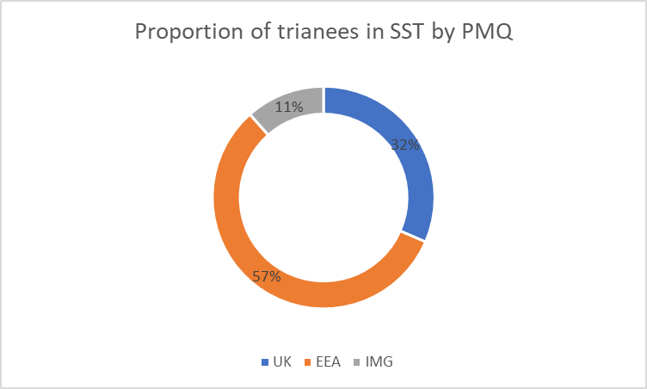

Male trainees were slightly more likely to be in SST programmes (6.1%) than female trainees (3.53%). This gap has widened compared to 2021 with 4.5% proportion of trainees that identified as male and 3.95% of trainees that identify as Female.

Out of Hours (OOH) and oncall work patterns:

In this report, 86% (60/70) of respondents took part in OOH rota with 66% taking up a full shift on call work pattern. 18% percent of respondents only provided cover for their specialty during out of hours work. This represented a slight decrease compared to 2021 where 92.6% (50/54) of SST respondents reported yes for taking part in OOH rota.

Average monthly impact on SST:

Despite respondents spending less time on non-subspecialty sessions, there was no significant difference in lost compensatory rest days to attend training opportunities or in lost subspecialty sessions due to compensatory rest days. In 2022, 47.1% (33 out of 70) of respondents spent sessions (half days) on non-subspecialty sessions monthly. This represented a marked decrease compared to just 66.1% (33 out of 54) of respondents in 2021.

Regarding lost subspecialty sessions, 80% (56 out of 70) of respondents lost subspecialty sessions due to zero days/compensatory rest, compared to 83.3% (45 out of 54) in 2021 (range: 1-24 half days per month). Furthermore, 68.6% (48 out of 70) of respondents in 2023, compared to 64.8% (35 out of 54) in 2021, did not take zero days/compensatory rest to attend training opportunities (range: 1-15 half days per month).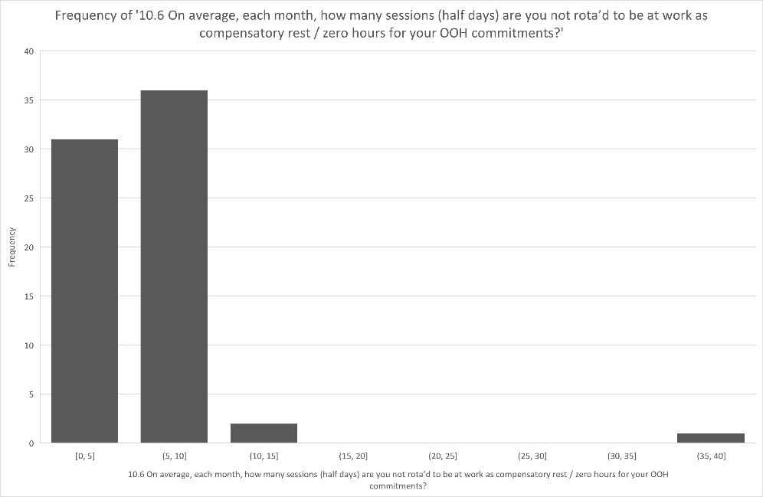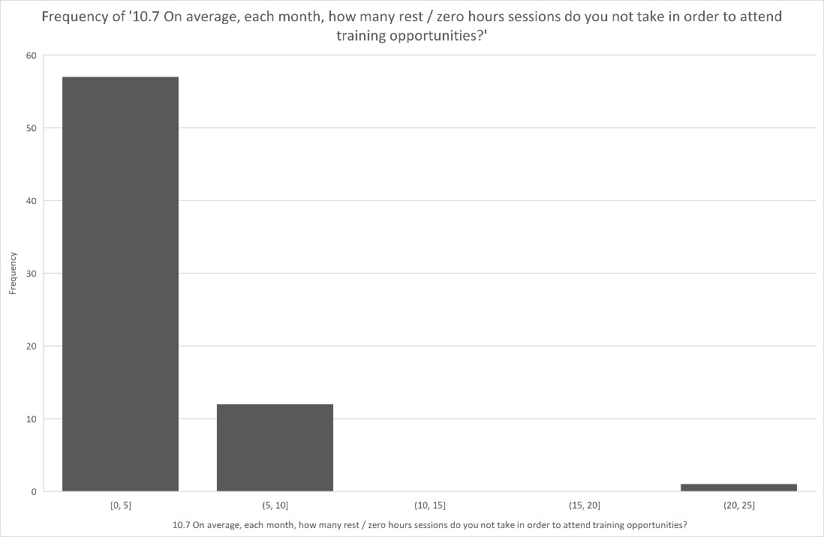

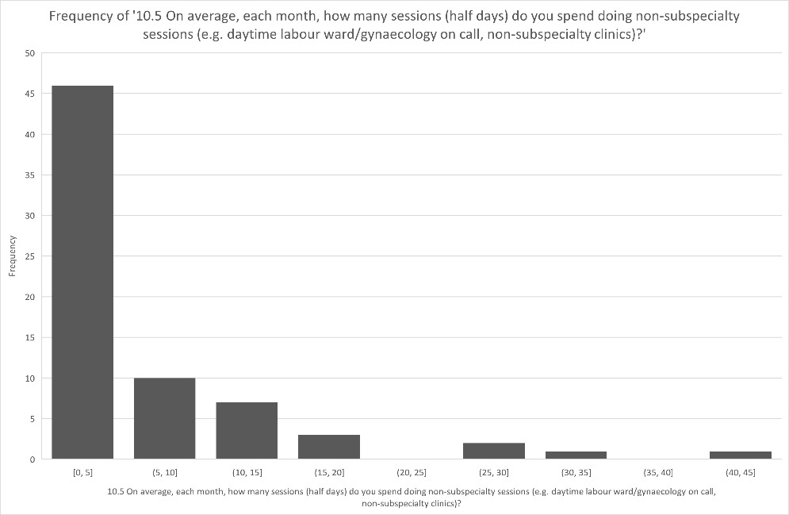

In this report, 42% (compared to 38.9% in 2021) of respondents either agreed or strongly agreed that OOH commitment does not have a negative impact on their training. 26 (37%) respondents felt that out of hours work had a negative impact on their subspecialty training. They either disagreed or strongly disagreed with the opinion ‘My OOH commitment does not have a negative impact on training'.

Only 13% of respondents did not feel that their rota allowed opportunity to undertake all aspects of their subspecialty training programme. 70% of respondents rarely missed specific sessions to cross cover commitments.





SST requirements:

12 of the 70 respondents (17%) reported extensions to their subspecialty training beyond the initial projected completion date. This represented a slight decrease from 20.1% (11 of 54) in 2021.

10 (14%) respondents were unable to meet all their SST requirements in their training unit of which 8 were able to gain the required experience in another unit.

Subspecialty training programme director:

In this report, 96% (67 of 70) of respondents found their programme director approachable while 94% (66 of 70) found the programme director to be supportive as well as having taken part in regular and constructive appraisals and 93% (65 of 70) found that the programme director has been a good teacher. These numbers are largely unchanged from those found in 2021.

|  |  |
| --- | --- |
| **10.12.1 My subspecialty training programme director has been approachable** | **Count of Rows** |
|  |  |
| Strongly agree | 49 |
| Agree | 18 |
| Neither agree nor disagree | 2 |
| Disagree | 1 |

|  |  |
| --- | --- |
| **10.12.3 My subspecialty training programme director has been supportive** | **Count of Rows** |
|  |  |
| Strongly agree | 51 |
| Agree | 15 |
| Neither agree nor disagree | 3 |
| Disagree | 1 |

|  |  |
| --- | --- |
| **10.12.4 My subspecialty training programme director has taken part in regular and constructive appraisals** | **Count of Rows** |
|  |  |
| Strongly agree | 47 |
| Agree | 19 |
| Neither agree nor disagree | 3 |
| Disagree | 1 |

The majority of respondents would recommend their training units to other potential SSTs.

|  |  |
| --- | --- |
| **12.1.17 All things considered I would recommend this centre to other trainees who wish to attain gynaecology subspecialty training** | **Count of Rows** |
| Strongly agree | 14 |
| Agree | 5 |
| Disagree | 1 |

|  |  |
| --- | --- |
| **13.1.15 All things considered I would recommend this unit to other subspecialty trainees in Maternal and Fetal Medicine** | **Count of Rows** |
| Strongly agree | 20 |
| Agree | 4 |
| Neither agree nor disagree | 1 |

|  |  |
| --- | --- |
| **15.1.20 All things considered I would recommend this unit to other subspecialty trainees in Urogynaecology** | **Count of Rows** |
| Strongly agree | 4 |
| Agree | 3 |
| N/A | 1 |
| Neither agree nor disagree | 1 |

Urogynaecology simulation training:

In this report, 11% (1 of 9) did not have access to either a box trainer or a virtual reality simulator. This represents an improvement from 2021, where only 1 of 7 reported not having the same access. Additionally, 56% (5 of 9) in 2022, compared to 6 of 7 in 2021, did not have a formal program of simulation training in gynaecological procedural skills. While this demonstrates a significant improvement, there is still much more work to be done in this area.

|  |  |
| --- | --- |
| **15.2 I have had access to a laparoscopic box trainer or virtual reality simulator** | **Count of Rows** |
| Yes, box trainer only | 6 |
| No | 1 |
| Yes, virtual reality simulator only | 1 |
| Yes, box trainer & virtual reality simulator | 1 |

|  |  |
| --- | --- |
| **15.3 There was formal programme of simulation training in gynaecological procedural skills** | **Count of Rows** |
| No | 5 |
| Yes | 4 |

**Gynaecological Oncology**:

|  |  |
| --- | --- |
| **12.3 There was a formal programme of simulation training in gynaecological procedural skills** | **Count of Rows** |
| No | 13 |
| Yes | 7 |

In this report, 35% (7 of 20) did not have access to either a box trainer or a virtual reality simulator. This represents a significant increase from 2021, where only 1 of 16 reported not having the same access. Additionally, 65% (13 of 20) in 2022, compared to 11 of 16 in 2021, did not have a formal program of simulation training in gynaecological procedural skills.

|  |  |
| --- | --- |
| **12.2 I have had access to a laparoscopic box trainer or virtual reality simulator** | **Count of Rows** |
| No | 7 |
| Yes, box trainer only | 6 |
| Yes, box trainer & virtual reality simulator | 5 |
| Yes, virtual reality simulator only | 2 |

Summary of findings

In this report as well as the 2021 report, high levels of overall satisfaction were reported by SSTs with clinical supervision, the trainers teaching them, the SST training programme directors, and the majority of responders would recommend their centre to other potential SSTs.

Some concerns were flagged about specific opportunities in certain centres not being available. For example, in GO 4/20 did not have adequate exposure to fulfil training in laparoscopic procedures. In MFM, 3/25 did not have adequate exposure to neonatal surgery. In UG, 4/9 did not have adequate opportunity to develop their laparoscopic urogynaecology skills, and 4/9 did not agree that opportunities for major procedures had been available. This likely reflects the greatest issue with the lag in training opportunities following the Covid pandemic.

Out-of-hours (OOH) commitments have been previously raised as an issue. Less than half of respondents (47%) of SSTs reported doing non-subspecialty sessions, which represented a significant improvement from 2021. However, other issues continue in this survey, with 86% participating in OOH commitments. Eighty percent (compared to 83% in 2021) lose subspecialty sessions as a result of zero days or compensatory rest, and 69% (compared to 65% in 2021) do not take zero days to attend training opportunities. These figures are similar to the 2021 survey. Despite the similar numbers, only 37% (compared to 61% in 2021) think the OOH commitment has a negative effect on training. This represents a significant improvement in SST. Although it is not immediately clear what factors might have contributed to this finding.

Simulation training was raised as an issue in the 2021 report. Access to box trainers actually appeared to be significantly worse compared to 2021 for GO SSTs, and most respondents did not have a formal program of simulation training in gynaecological procedural skills. Given the pressures on surgical exposure arising from the pandemic and the need for training recovery, this is disappointing and an area to be addressed. Despite raising these issues as actions following the previous TEF, there does not appear to have been significant change. Given changes in working practices owing to the Covid pandemic, it is not possible to say if previously noted issues have been addressed; however, this will remain a priority in future TEF analyses.

Recommendations

**Actions**

Recommended actions for SSTC and SST TPDs:

• Continue to monitor COVID impact on training

• Work with HEE and RCOG to look at EDI data

• Continue to monitor outcomes from centralised assessments and monitor trends

• Work with RCOG on Advanced Training Review (ATR) and new SST curriculum

References

RCOG ATSMs <https://www.rcog.org.uk/careers-and-training/training/curriculum/atsms/>

Advanced Training Definitive Document, RCOG 2019 <https://www.rcog.org.uk/media/xigldqq1/advanced-training-definitive-document-2019.pdf>

RCOG Subspecialty Training Curriculum <https://www.rcog.org.uk/careers-and-training/training/curriculum/subspecialty-training-curriculum/>

RCOG Advanced Training Review <https://www.rcog.org.uk/careers-and-training/training/curriculum/advanced-training-review/>

RCOG Advanced Training Review implementation planning March 2023 <https://www.rcog.org.uk/media/vfybceue/advanced-training-review-implementation-planning-march-23-1.pdf>

Currie, J, Drakeley, A, Guerrero, K Subspecialty Training RCOG TEF 2021 analysis <https://www.rcog.org.uk/media/a0dltqvf/tef-2021-report-subspecialty-report.pdf>

CiP Sign-off RCOG <https://www.rcog.org.uk/careers-and-training/starting-your-og-career/specialty-training/assessment-and-progression-through-training/cip-sign-off/>

RCOG Core curriculum for Obstetrics and Gynaecology: Definitive document 2019. <https://www.rcog.org.uk/media/aoleiujs/definitive-document-core-curriculum.pdf>

RCOG Matrix of progression 2022-2023. <https://www.rcog.org.uk/media/afzcgaep/2022-2023-training-matrix-progression-covid-19-st6-7-switched-to-2019-core-curriculum.pdf>

Ockenden review: Summary of findings, conclusions, and essential actions. March 2022. <https://www.gov.uk/government/publications/final-report-of-the-ockenden-review/ockenden-review-summary-of-findings-conclusions-and-essential-actions#immediate-and-essential-actions-to-improve-care-and-safety-in-maternity-services-across-england>

RCOG Roles and Responsibilities of the Consultant providing acute care in Obstetrics and Gynaecology. 2009. <https://www.rcog.org.uk/media/1e0jwloo/roles-and-responsibilities-of-the-consultant-workforce-report-may-2022-update.pdf>

Ultrasound Training. RCOG document. <https://www.rcog.org.uk/careers-and-training/training/curriculum/subspecialty-training-curriculum/ultrasound-module-intermediate-ultrasound-of-early-pregnancy-complications/ultrasound-training-introduction/>

Promoting excellence: standards for medical education and training. GMC 2015. <https://www.gmc-uk.org/-/media/documents/promoting-excellence-standards-for-medical-education-and-training-2109_pdf-61939165.pdf#page=17>

RCOG Educational supervisor: Job description. <https://www.rcog.org.uk/careers-and-training/training/resources-and-support-for-trainers/job-descriptions-for-rcog-educational-roles/educational-supervisor-job-description/>

New Curriculum. TEF report 2021. Accessed via <https://www.rcog.org.uk/media/hdmhnroq/tef-2021-report-curriculum-2019-educational-supervision.pdf>

Effect of the COVID-19 pandemic on training. TEF report 2021. Accessed via <https://www.rcog.org.uk/media/r5mjf400/tef-2021-report-covid-19.pdf>

Find out more at

rcog.org.uk

