Thematic Report
Differential Attainment

December 2023
Differential Attainment
Authors: Dr Nadia Muspratt-Tucker, ST7 Trainee, HEE Thames Valley region; Dr Lydia Akinola, ST4 Trainee, HEE Thames Valley region; Mr Rehan Khan, Consultant, HEE North Central and East London region

Introduction
The report presented here uses data from the GMC National Training Survey (NTS) and the RCOG TEF 2023.
Analysis of the data was complicated by the use of self-identification and gaps in data collection. These ‘blank’ entries have removed from consideration – but represent a significant proportion of responses. Some categories or response groups were tiny with only a handful of trainees selecting them – they too have not been included as the sample size is too small. Ultimately although the TEF is a rich survey, it is difficult to make conclusion about some of what we are investigating due to its limitations – the primary purpose is not to quantify differential attainment.

Demographics
Obstetrics and gynaecology in the UK is a diverse specialty with trainees from a range of backgrounds and lived experience.
Overall 60% of doctors in this specialty identify as female (the highest in any specialty), and amongst trainees 79% identify as female, 18% male, 0.95% non binary and 1.64% reported their gender identity is not represented in the above categories.

As a specialty obstetrics and gynaecology is one of only 2 specialties with increasing numbers of international medical graduate (IMG) doctors, and these are mostly trainees (86% increase in IMG trainees from 2017-2021 compared with 5% increase in UK trainees). (GMC workforce report).
Currently 20% of trainees in our specialty are international medical graduates from outside the EEA.
Among specialist doctors, O&G has the highest rate of leaving at 20% (GMC Workforce report).

Ethnicity

The proportion of white trainees has reduced from 57% in 2021 to 53% in the latest TEF and there has been a corresponding increase in trainees of Asian, Black and Mixed ethnicity.

Subspeciality training (SST)
3.5% of female trainees are currently in subspecialty training, compared with 6.1% of male trainees (an increase from 4.5% in the last report). However, female trainees make up 75% of all subspecialty trainees.
Black trainees comprise only 5% of subspecialty trainees despite accounting for 10% of trainees. This trend has remained unchanged since the last report.

Less than full time (LTFT) training
33% of trainees are training less than full time, compared to 30% last year. Amongst female trainees this number rises to 37% with only 14% of male trainees are training LTFT. While a smaller proportion of male trainees are training LTFT, this proportion has nearly doubled since 2021.

39% of white trainees are training LTFT compared to 32% of trainees of mixed ethnicity, 30% of Asian trainees and 19% of Black trainees. While there is still a difference between ethnicities, this has reduced since last year.

Support to exception report
55% of male trainees agreed that they were supported to exception report compared with 45% of female trainees. 14% of male trainees disagreed with this statement compared with 20% of female trainees.
There was similar degrees of support between white (46%) and non-white trainees (46%) as well as between UK and non-UK graduates (46%). Irrespective of background, more than half of respondents did not feel supported to exception report.

Support after adverse events
Overall, 72% of trainees agreed that they felt well supported by their unit when involved in a serious clinical incident or poor outcome. Amongst white trainees this was 75% and Asian trainees 70% . Amongst black trainees however it fell to 63% and 56% for trainees of mixed ethnicity.
Similar differences were found in this question when UK graduates were asked (74% agree) compared to international medical graduates (66% agree).

Appropriate opportunity to meet training requirements for the year
58% of male trainees agreed that they had appropriate opportunity to meet their training requirements for the year, compared with only 46% of female trainees

Fair distribution of training opportunities
Whereas 63% of white trainees agreed with the statement ‘Training opportunities are distributed fairly’, only 50% of Asian trainees, 53% of black trainees and trainees with mixed ethnicity agreed. Non-white trainees were also more likely to disagree with the statement. 61% of UK graduates agreed, compared with 46% of non-UK graduates.

Valued in the workplace
Overall, 75% of trainees felt valued in the workplace. Amongst UK graduates this was 77% compared with 69% for international medical graduates. Women were also less likely to feel valued in the workplace, with 75% agreeing compared to 81% for male trainees.

Discrimination
82% of trainees agreed with the question “I have NOT been discriminated against in my training”. This figure was similar for both male and female trainees.
For white trainees, 90% agreed that they had not been discriminated against in their training. This figure fell for other groups, with 83% of mixed ethnicity trainees agreeing, 77% of Asian trainees and 67% of black trainees agreeing that they had not been discriminated against.

When asked ‘ I have NOT been subjected to persistent negative behaviours, 8% of white trainees disagreed. However, this proportion was double in Asian and Mixed ethnicities backgrounds (16% and 17%) and remained higher in black trainees (13%).

Examinations
- Ethnicity
Candidates from White groups were more likely to pass the MRCOG than those from non White groups. This finding was more pronounced among candidates who were international medical graduates (IMGs) when compared with UK graduates. These findings are consistent with all other postgraduate medical examinations in the UK. GMC datasets have changed in terms of how data is collected, so comparison with previous years to look for trends is difficult.

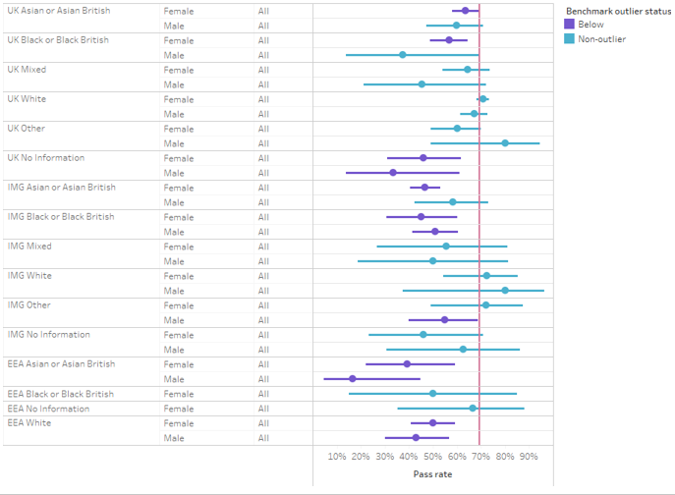

- Gender, Deprivation and Age
Candidates from more deprived groups were generally less likely to pass the MRCOG than those from less deprived groups. Exam candidates older than 34 appear to have significantly lower pass rates. Candidates identifying as male were significantly less likely to pass than those identifying as female.
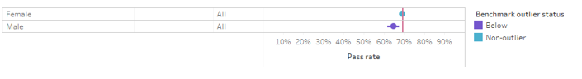
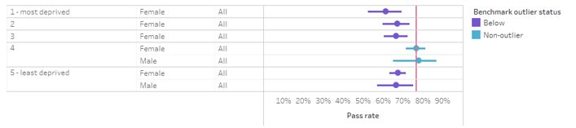
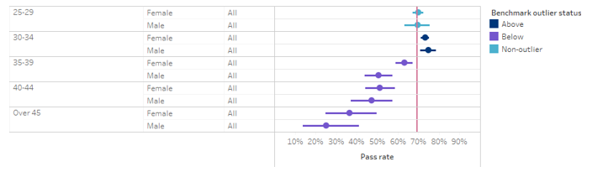

ARCP outcomes
- Ethnicity
There has been considerable change in ARCP outcomes for O&G trainees over the last five years. When the college first started examining differential attainment, all non White groups including UK graduates had a significantly lower chance of a successful outcome. The gap between White and non White groups has narrowed, and only persists among IMGs.
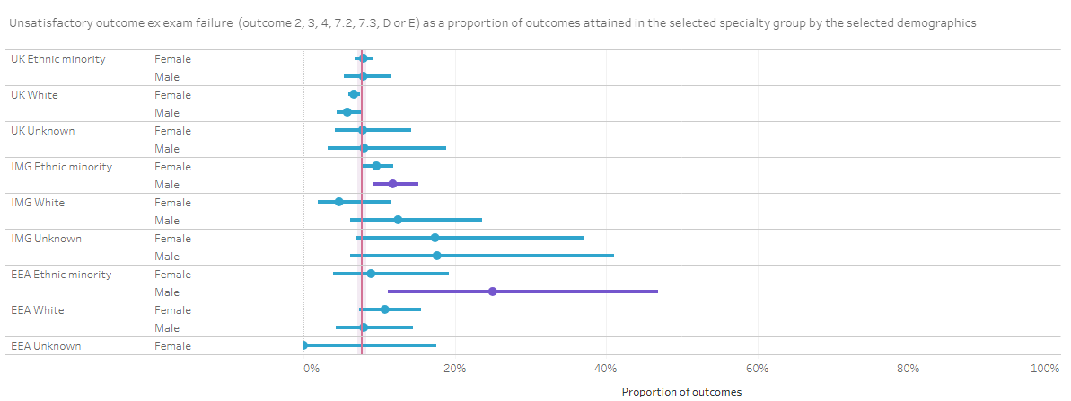
- Gender, Deprivation and Age
There is no difference in ARCP outcome by deprivation or gender, but the same differences observed in exam pass rates according to age are seen in ARCP outcomes
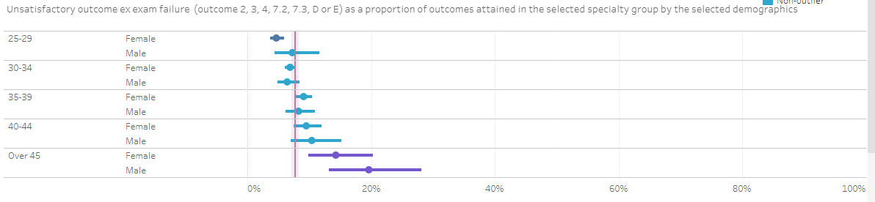

Conclusions
Within the scope of the TEF and GMC survey there are some limitations – numbers of trainees who identify as non-binary, trans or other gender identity are small and therefore numbers are difficult to interpret on this survey. Similarly, the numbers of trainees who report having a disability are small and therefore analysis is limited.
There remains work to be done to improve differential attainment amongst trainees in Obstetrics and Gynaecology. There have been significant improvements in a number of parameters over the last few years, in particular with regard to ARCP outcomes, however in some areas differences have persisted and more focused work is needed.

Recommendations
- Work into understanding the impact of increasing numbers of international medical graduates and consider creating bespoke support structures and networks to help facilitate their transition into the UK workforce. This should include particular support for ARCPs and examinations.
- Investigate the barriers in undertaking sub-speciality training that that female trainees and trainees from ethnic minorities may face.
- Explore the barriers that trainees have towards exception reporting and encourage heads of Schools and College Tutors to promote exception reporting.
- With ongoing unrest with industrial action and Covid recovery, a quarter of trainees do not feel valued. The College should look at initiatives that promote trainee appreciation, look at ways to recognise clinical and academic excellence but also great interpersonal skills. Improving workplace morale should be a standing item on School Board agenda with a dedicated lead for wellbeing.
- Ongoing transparency about how training opportunities are made, advertised and distributed.
- Ongoing education about the role and purpose of TEF to help reduce bias and eliminate data gaps.

Find out more at
rcog.org.uk

